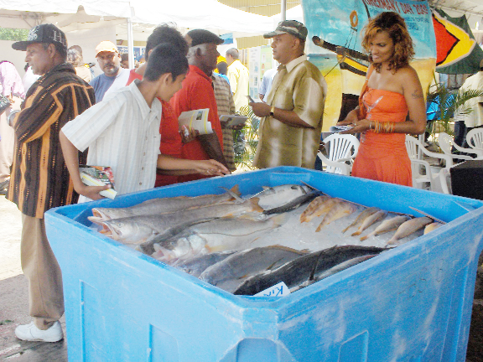
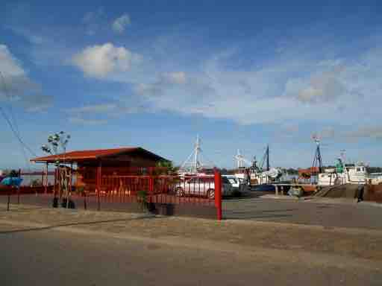
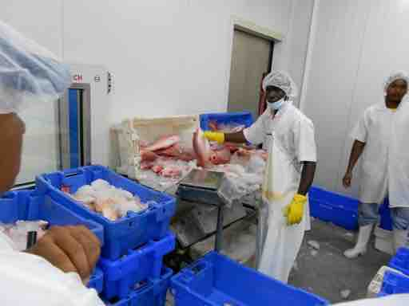
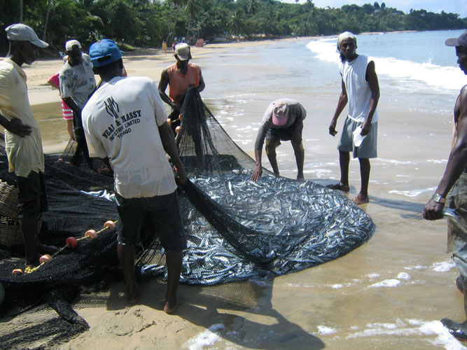

Suriname

Mission Report
+

Project: Technical support to develop model legislation, protocols, guidelines for health and food safety related to fisheries and aquaculture in CARIFORUM States
Funded by the European Union
Managed by the International Institute for Cooperation in Agriculture (IICA) and the Caribbean Regional Fisheries Mechanism (CRFM)
July 2015


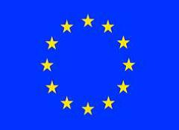

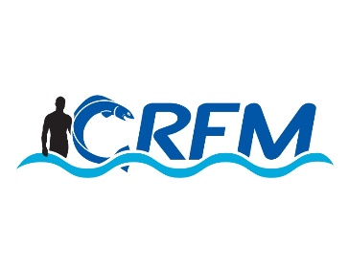
Contents

Mission Activities 2
Meeting Notes 2
Inception Meeting (Fisheries Division, TNINT Representatives) 2
Site Visits 3
National Consultation 4

Mission Activities

- A mission to Suriname was undertaken during the period June 3-7 2015. The Team members included Team leader and Legal Consultant Mr. Chris Hedley, and Dr. George Grant, SPS consultant.
- The following meetings were organized:
- Inception meeting, with officials from the Fisheries Department, along with other representatives from the TNINT, the Director of CAHFSA and representatives of IICA.
- Site visits to the Fishery Inspection Institute and two fish processing facilities (CEVIHAS and Onacro)
- the National Consultation.

Meeting Notes

Inception Meeting (Fisheries Division, TNINT Representatives)
The consultants met with the several technical staff personnel from the Department of Fisheries headed by the Chief Fisheries Officer (Director of Fisheries).
The visiting team members were welcomed by the Director of Fisheries and senior staff personnel of the Department .In response Mr. Hedley thanked the members of staff for their facilitation and went on to make a brief presentation on the rationale, aim, and deliverables of the consultancy and the consultants expectations with respect to the staff feed back of their own perceptions of SPS measures in Suriname and their own expectations and aspirations with respect to the project’s potential impact on the safety and competitiveness of the country to trade its fishery products.
The Director of Fisheries gave a synopsis of the current status of the Fisheries Sector in Suriname.
The Director pointed to the two components of the Fishery Department namely, the Administrative/Management and the Fisheries Inspection Institute (FII) an autonomous entity with responsibility for inspection and laboratory services and with public health linkages. An Aquaculture component was recently added to the Department.
Other highlights of the presentation included :
- Suriname is one of the major fishing country of the CARIFORUM group of countries
- No formal fisheries, food safety or fish health polices presented or are in place, although there a documents and strategies which informally make up the national policies.
- Draft Aquatic Legislation is in progress, with associated regulations and Ministerial “decrees” to regulate he aquaculture sub-sector
- Code of practice for fish production on the” high seas”
- Fisheries Act in place
- Suriname gained EU approved status in 2007.
- Levy placed on all fish product export operations
- Fishery Sector contributes approx.55%of agriculture’s contribution to the country’s GDP .
- Estimated average national annual fish production 35-40 ,000 Tonnes
- Fishery harvesting fleet of approx.1000 artisanal type vessels,40 trawlers and 30 snapper harvesting - type vessels
- Venezuelan , Chinese, Korean and Panamanian -flagged vessels engaged in the fishing operations.
- Fishery operation inclusive of Estuary , Coastal , High seas and aquaculture were used as the official concept of zoning.
CAHFSA
- The consultants met with Mr. Simeon Collin , Director of the Caribbean Regional Agricultural Health and Food Safety Agency (CAHFSA) .The Director expressed his support for the project which he believed will positively impact the agency and wished for a firm linkage with the CRFM. He also noted that CAHFSA was also colabor5ating with the regional standard setting body CROSQ to develop relevant food safety standards and that in fact some of the standards were already available. It was noted that this particular agency was not yet fully operational. The issue of management of the standards by either CROSQ or CRFM or the two agencies combined was explored in light of the new paradigm shifts in agricultural health and food safety systems.
IICA
- The consultants visited with and had useful discussions on the consultancy and other relevant issues with the Suriname IICA Country representative ,Dr. A. Abiola who gave his full support to the visiting mission team

Site Visits
Fishery Inspection Institute
The Director Ms. Cowley updated the consultants on the operation of the Institute, as well as ,gave a guided tour of the facilities. The facility is still in need of additional equipment, material and expertise so as to become more functional. The laboratory is currently not accredited but preparations are reportedly in progress. In general limited resources seen as a main militating factor.
Processing Facilities/Landing sites/Aquaculture Farm
The Consultants were given a tour of two of the fish processing facilities namely, the private sector operated CEVIHAS and Onacro, primarily an export- oriented operations and the Government operated Fish processing facility .
These facilities are currently EU approved. The consultants also observed the operations of one of two fishermen landing sites(docks) and viewed the different categories of fishing vessels. In addition a visit was made to the Fish Vending Market.
A special visit was also paid to the Amazon Aquaculture farm one of the stated three active farmed fish enterprise in the country. It was noted that aquaculture production is only now being resuscitated and expanded as a needed alternative fishery seen with great export potential.

National Consultation
This particular consultation was hosted by the Department of Fisheries and featured a wide cross section of the operators in the fishing industry. In attendance also were representatives from IICA, the Fish Inspection Institute, Aquaculture Section and other technical personnel from the Fisheries Department
The consultants in their presentation reiterated the aim of the consultancy and the expected outcomes re a strengthening of the Member States legislative and SPS capacities to effect greater trade competitiveness at the market place both regionally and internationally.
The urgent need for relevant mechanisms to drive a regional approach was issued. The importance of stakeholders involvement in terms of a feedback on the ongoing consultancy was emphasized
Presentations were made by the Chief Fisheries Officer, the Head of the Fish Inspection Institute and the head of the newly formed Aquaculture section.
These presentations sought to give a historical sketch of the current status of the Surinamese Fishing Industry and the SPS Progamme at work in the Industry. The presentations also pointed to the various challenges, issues and concerns re faced in maintaining an acceptable of level of SPS compliance .The problems of IUU non compliance were noted as well as the difficulties of enforcement.
A lively and frank series of discussion ensued after the several presentations. It was noted that Suriname having accorded EU- approved status must now make the necessary effort of maintain its status and in so doing expand its market access. The mission as well as the consultancy were considered to be timely and relevant events which could positively impact Suriname initiatives to improve the fishing sector which accounts for a significant input into national development.
Some of the major findings coming out of the consultation workshop in terms of challenges ,limitations ,concerns and opportunities were as follows:
- Implications of Impending EU inspection visit
- Validating , maintenance and strengthening of current SPS programmes
- Laboratory capabilities and accreditation challenges
- Official Artisanal participation in export activities via compliance measures
- Marketing access for smoked and salted fish products
- Local Fish market conditions-both infrastructural and sanitation
- SPS programme for Aquaculture operations not in place
- Traceability programme
- Bio-security measures
- Use /regulation with respect to SPS of Suriname foreign flagged harvesting vessels
- Status of Member states fisheries trade
- Regional transportation as it applies to the fishing trade.
- Animal welfare (aquaculture in particular)
- Artisanal fishers organizations /participation
- Difficulty of Access to capital /high interest rates to fishers
- On-going auditing/validation of SPS system in place.

