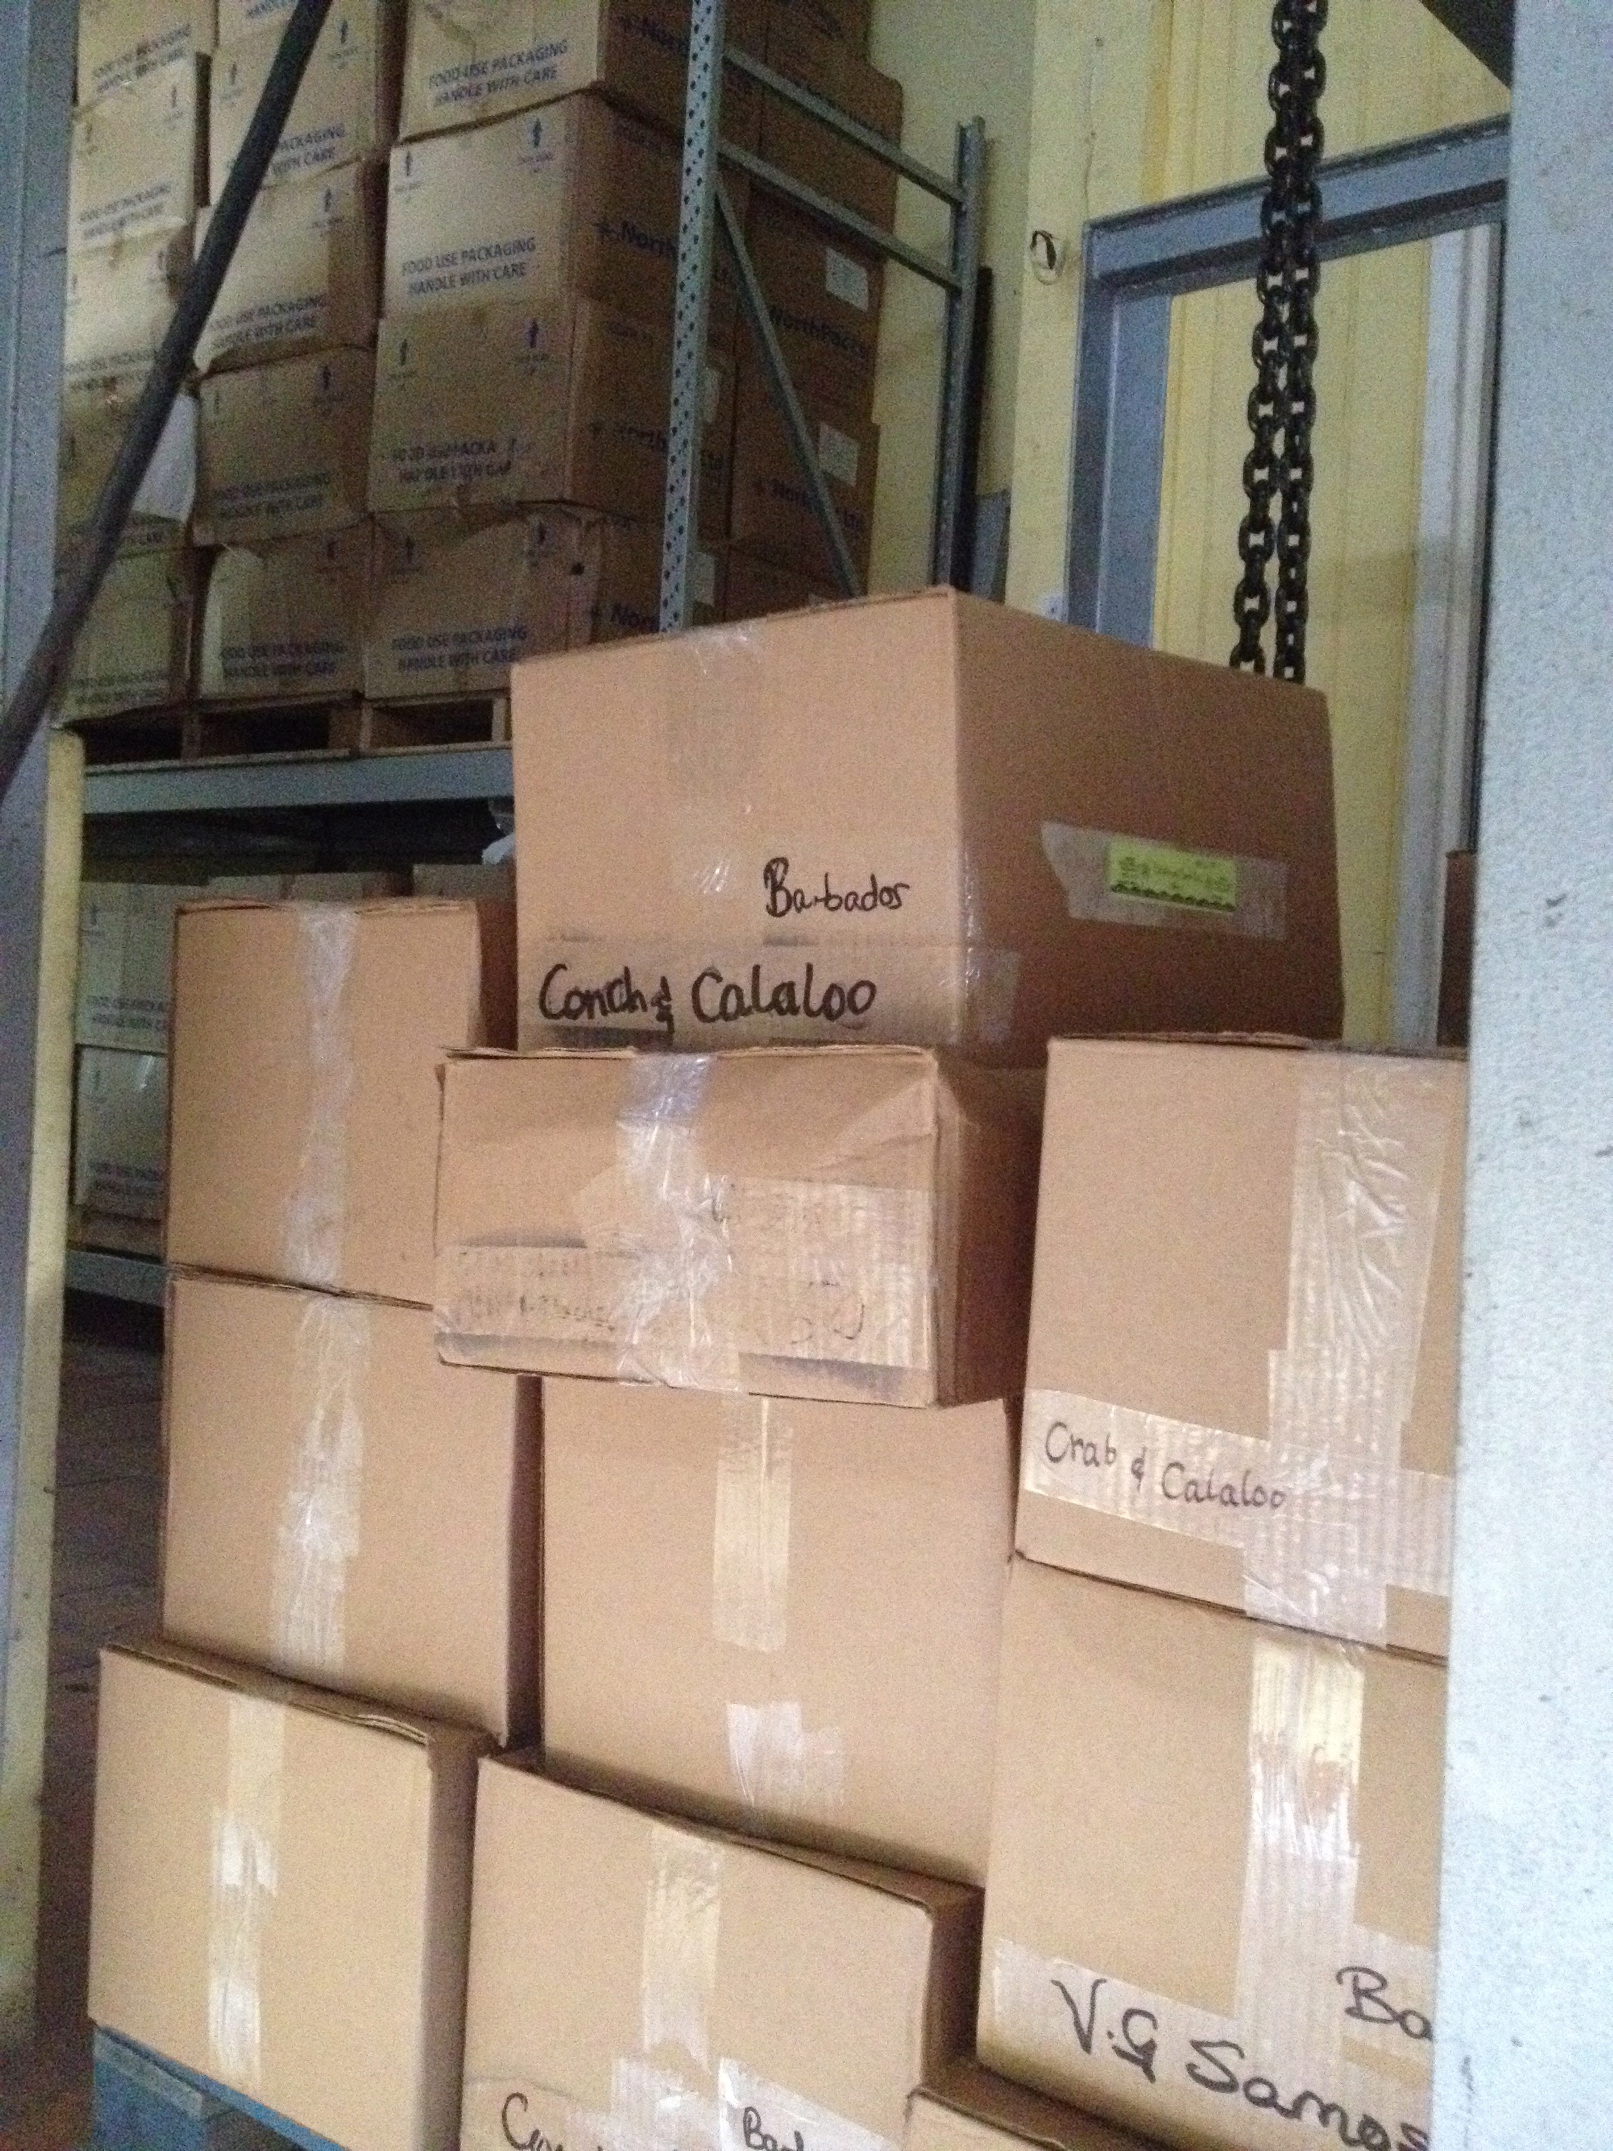
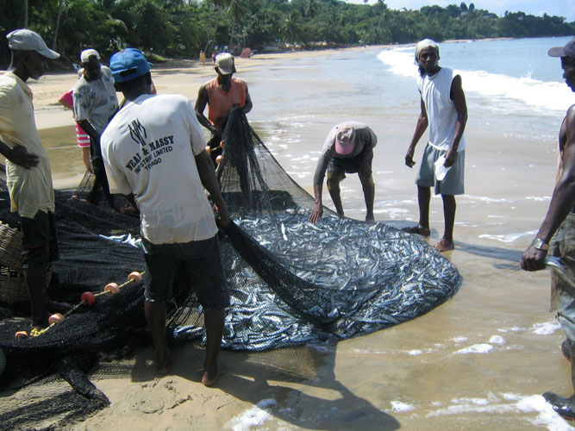

Saint Vincent & The Grenadines

Mission Report
+
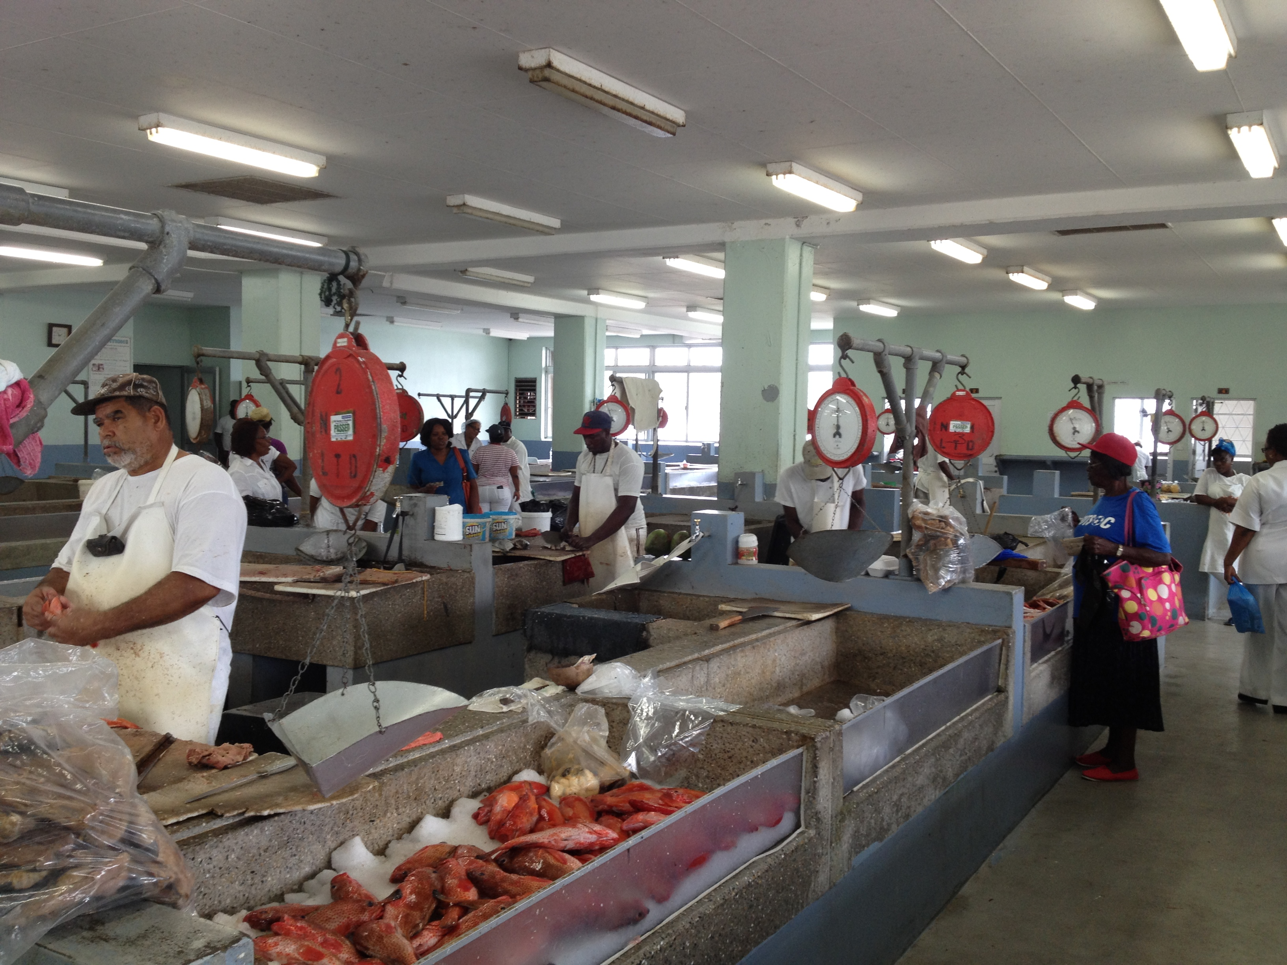
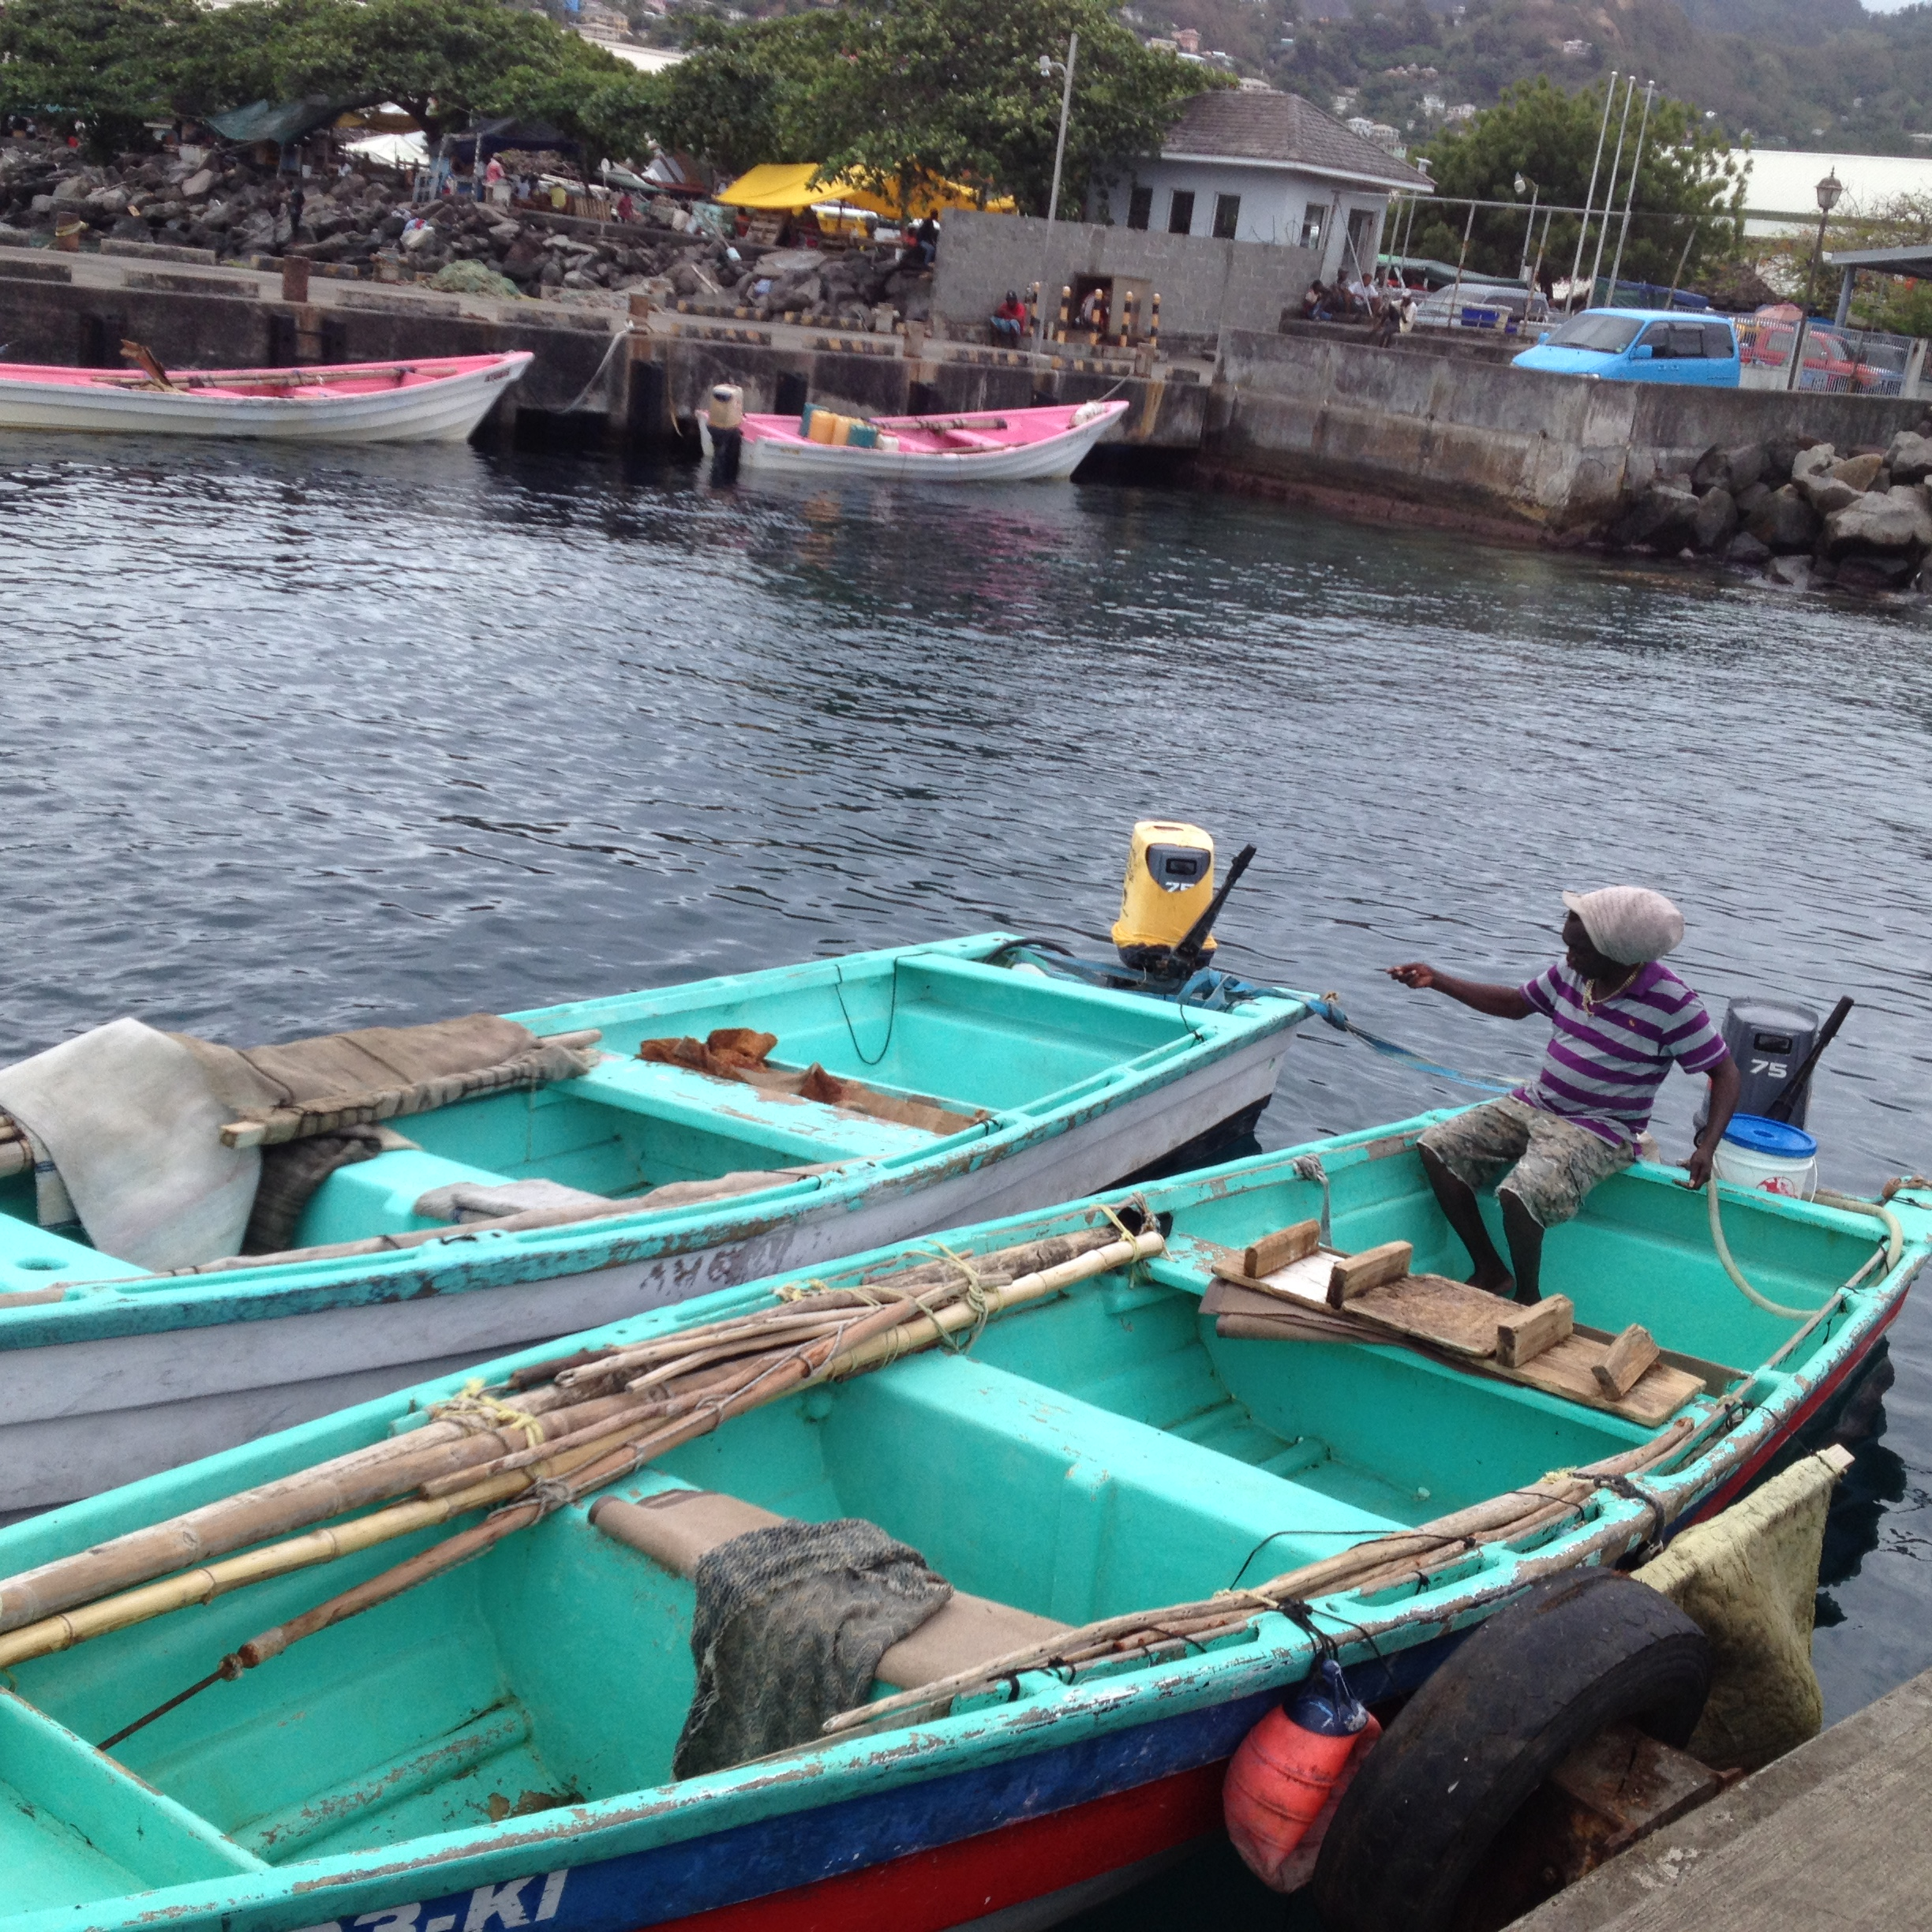

Project: Technical support to develop model legislation, protocols, guidelines for health and food safety related to fisheries and aquaculture in CARIFORUM States
Funded by the European Union
Managed by the International Institute for Cooperation in Agriculture (IICA) and the Caribbean Regional Fisheries Mechanism (CRFM)
July 2015




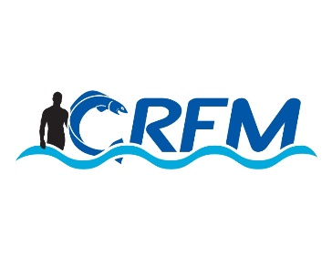
Contents

Mission Activities 3
Meeting Notes 3
Meeting with Fisheries Division 3
Appendix | Document Lists 6
Documents Collected 6

Mission Activities
The mission visit was undertaken during the period June 26-29, 2015. The mission team comprised Mr. Chris Hedley, Team Leader and Legal Consultant, Dr. George Grant and Dr Susan Singh-Renton, Deputy Executive Director of the CRFM.

Meeting Notes

Meeting with Fisheries Division
At this meeting, chaired by Dr. Lucille Grant (CFO),the participants were briefed on the overall CRFM/IICA Programme with the Deputy Director of the CRFM ,Dr. Susan Singh –Renton pointing to the fact that the Legislative and SPS Consultancy dealt with only one of four components of the overall project but that in fact they were all linked and aimed at strengthening the capacities of CARIFORUM member states to access the global market for fishery products.
Following this, presentations were made by (a) the Consultant Team Leader, Mr. Chris Hedley, who briefed the participants re the rationale, aim and expected deliveries of the consultancy and the need for stakeholders feed back to inform the consultancy; and (b) the Chief Fisheries Officer which gave an update of the current SPS /legislative status of the Fisheries Sector.
Some of the important points re the challenges and limitations faced, as well as, the existing opportunities to change course were identified as follows:

- Importance of the Fishery Sector to the country’s economy (supplying approx 55% of agricultures’ contribution to national GDP).
- Non approval of SV/G as an EU export listed country. (Access to EU denied since 2000)
- The country still is preparing for EU approval, but is hampered by inadequacy of resources to undertake acceptable levels of SPS measures, inadequacy / difficulties of monitoring and enforcement systems, lack of laboratory support services and lack of legislative enforcement capacity.
- Fisheries Division now responsible for management and inspection of the Fishing Industry and recently fish public health . The latter through an official MOU between the Ministries of Health and Agriculture.
- A Procedural Manual for Official fishery product controls is in place, but is inconsistently applied and monitored. There is a lack of full implementation of HACCP and Prerequisite programmes.
- Questions on the comparative costs of SPS implementation (disillusionment re 15 year lapse since EU access)
- Complaints re retooling of facilities due to lack of access to capital/burdensome interest rates.
- Lack of regional coordination /difficulties in intra Member country trading/transportation woes
- Country trying to make good deficiencies pointed out in EU last inspection evaluation report.

TNINT/NAHFSC Meeting
The visiting consultants once again gave a brief review of the consultancy in terms of its aim and expected outcomes through the Legislative and SPS Capacity strengthening of CARIFORUM member states and the development of mechanisms for regional coordination and governance.
This was in addition to the rationale for the mission visit that of getting key participants response and feedback which will serve to inform the under taking of this component of a larger CRFM project.
Similarly Dr. Singh-Renton in her capacity of Deputy Director of the CRFM gave a synopsis of the other programme components and spoke to the linkages of all four components which are aimed at putting CARIFORUM member states in a superior position to access and maintain a presence in the global market place by being compliant with acceptable international standards of quality and safety of fishery products to the consuming publics.
Through discussions a specific factors were identified as to the current management, governance and attempts at enforcement of SPS measures in the St Vincent and the Grenadines.
Some of the topics highlighted were:

- Multiplicity of agencies impacting food safety.
- Myriad of legislative pieces impacting food safety.
- Resources limitation
- Attempts at coordination via NAHFS Committee
- Deficiencies in governing regulations
- Need for more documentation of actual protocols and procedures in use .
- Need for improved Laboratory resource system via utilization of a combined approach to existing laboratory utilization both nationally and regionally (S o-called centre of excellence to be explored)
- Increased training of specialist personnel to man the system.
- Updating of legislation to achieve greater compliance and enforcement

National Stakeholders Consultation Workshop/Meeting
The National Stakeholders Consultation was held at the Fisheries Division Conference Room in Kingstown. The meeting saw a broad spectrum of operators in the Fishing Industry in attendance which include representatives from the Marine Police/Coast Guard Units. They were joined by several of the technical personnel from the official Fisheries Services.
The first presentation was that given by Mr. Chris Hedley Legal consultant and Team Leader who gave an introduction to the aims objectives, strategies expected deliverables / outcomes of the consultancy and rationale for the country visit as well as the need for feedback from the participants.
This was followed by presentations from the Chief Fisheries Officer who reported on the current status of the Fishing Industry in St. Vincent and the Grenadines and spoke to the many challenges of legislative enforcement, monitoring and governance and resources limitation, within the system.

During the follow-up discussions many of the participants related their experiences and expressed their willingness to cooperate with the Competent Authorities to work for EU compliance and general improvement in the industry given its importance to their lives and to the nation in general.
Some of the issues , challenges and concerns of the stake holder groups were as follows:
- Logistics for transshipment - movement of fisheries among CARICOM member states.
- Concerns about the inability to see harmonious trade protocol arrived at by member states
- Undertaking and financing of an effective laboratory support system -appropriate user fee system to be considered.
- Artisanal participation in export initiatives –method of compliance with at least the minimum acceptable SPS standards.
- Current status of Fish Cooperatives
- Capital for investment or retooling of facilities –high interest rates

Debriefing Session
A brief debriefing session was held at the Office of CRFM Deputy Executive Director. At this particular meeting the consultants gave a synopsis of their findings and an overall impression of the mission to the country.

Site Visits
The consultants undertook guided tours of the St Vincent government operated Fish Market and fish processing facility as well as visits to a fish processing facility owned and operated by a group of fishermen. A visit was also made to a local food processing facility.

