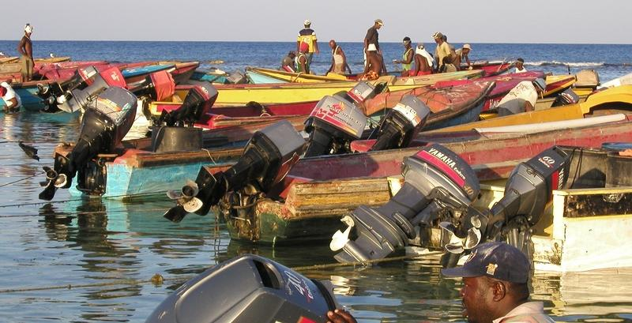

Jamaica

Mission Report
+

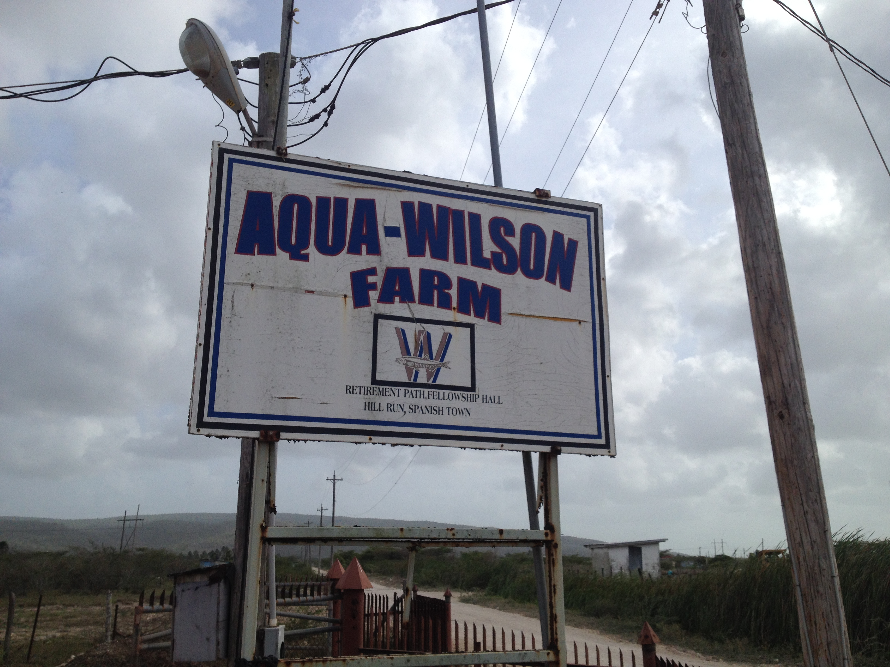
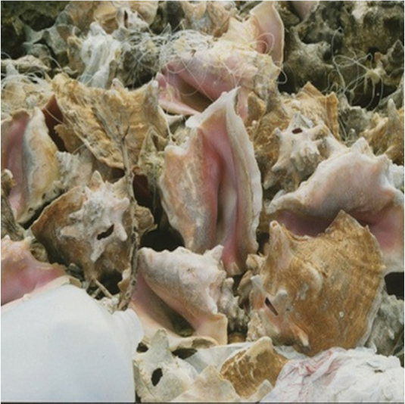

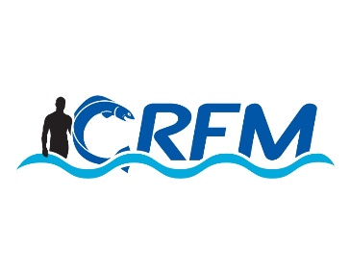
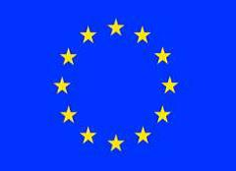


Project: Technical support to develop model legislation, protocols, guidelines for health and food safety related to fisheries and aquaculture in CARIFORUM States
Funded by the European Union
Managed by the International Institute for Cooperation in Agriculture (IICA) and the Caribbean Regional Fisheries Mechanism (CRFM)
July 2015

Contents

Mission Summary 2
Meeting Reports 2
Appendix | Document Lists 5

Mission Summary
- A mission to Jamaica took place from 28 April – 2 May. The mission team comprised the Project Team Leader (Chris Hedley) and KE2 (George Grant) and CRFM Programme Manager (Peter Murray).
- The following meetings and visits were organised:
- Meeting with senior staff from the Department for Marine Resources
- Meeting with drafting lawyer from the Attorney-General’s Office (responsible for drafting new SPS Bills)
- Meeting with the national SPS Committee (in effect, the TNINT), comprising representatives from BAIC, IICA, EH, BMEA, DoA, Agriculture Producers groups (this meeting formed the national consultative workshop – see below).
- Visit to a key production establishment - Tropical Seafood.
- Due to the short-notice of the mission, it was not possible to organize meetings with other stakeholders but the mission team was nevertheless able to get a good understanding and appreciation of the national context.

Meeting Reports

Bureau of Standards

- Chris Hedley (Legal KE & Team Leader), Dr. George Grant (SPS KE), Peter A Murray (CRFM Secretariat representative)
- Garth Smith;
Introduction to the consultancy by Chris Hedley
- Overall objective; purpose; results to be achieved, outputs
- Approach to consultancy including anticipated timeline
- Topics for discussion
- Issues/challenges and related Main SPS programme activities
  - Links to Environmental Monitoring consultancy (EM team to visit The Bahamas, Belize, Dominican Republic, Guyana, Jamaica, St. Kitts and Nevis, Saint Lucia, and Suriname)
  - Regional coordination and economies of scale; sharing of facilities (laboratories); accreditation.
BSJ Inspectors’ thoughts on legislative and coordinating requirements for SPS in the fisheries sector
Challenge of meeting EU standards by exporters who are exporting to non-EU countries (e.g.US): need to streamline regulations to meet various challenges; there are other countries to which trade is taking place but which have less stringent requirements. Need to choose the best regulatory tools to meet national strategic goals.
BSJ inspects pursuant to the Processed Foods Act (context: food processing plants), but has recognised that some regulations are outdated. Bureau role in context of local processing establishment BSJ role is in registration while Fisheries does the permitting.
Regional trade is also a burning issue that has to be considered. Coordination at the regional level dependent on market needs should be considered including to the extent that consolidation (of exports) can be achieved given the variance in national level standards (and also mindful of Revised Treaty of Chaguaramas and/or CSME).
Role of BSJ and similar agencies, given Jamaica’s stated sectoral development thrusts (i.e. species other than conch and lobster), might be in providing support to fisheries in development of codes of practice and regulatory frameworks; but resources currently preclude actual direct involvement in the regulatory process. Fisheries should initiate involvement of the relevant agencies; this begs the question of the need for MoUs between agencies.

Meeting with EU Delegation

Courtesy Call of EU Delegation
- Chris Hedley (Legal KE & Team Leader), Dr. George Grant (SPS KE), Peter A Murray (CRFM Secretariat representative), Stacy-Ann (Ministry of Agriculture)
- Koenraad Bruie (EU Delegation)
Introduction to the consultancy by Chris Hedley
- Overall objective; purpose; results to be achieved, outputs
- Approach to consultancy including anticipated timeline
- Related Main SPS programme activities
- Links to Environmental Monitoring consultancy (EM team to visit The Bahamas, Belize, Dominican Republic, Guyana, Jamaica, St. Kitts and Nevis, Saint Lucia, and Suriname)
Discussion
As a courtesy call, the main thrust of the meeting was providing M. Bruie with information regarding the consultancy. It appeared, however, that he did not appreciate how the content and outputs of the consultancy related to his work as Trade Attaché. IUU fishing also appeared to be a significant issue.

Debriefing Meeting – Fisheries Division

- Chris Hedley (Legal KE & Team Leader), George Grant (SPS KE), Peter Murray (CRFM Sec)
- André Kong (Director of Fisheries), Avery Smikle (Head, Aquaculture Branch), Shellene Berry, T’Chala Joevankar, Anna Ebanks, Stacy-Ann Gray, Charlene Thomas, Kimberlee Cooke-Panton, Dowen Wynter, Farrah Hansel.
CH: Noted excellent job done by FD on short notice.
Smikle: Clarified issue related to historical status of aquaculture. 2007 lost export market to EU and UK (not priced competitively). Draft fisheries bill should comprehensively address aquaculture. Policy to bring back aquaculture to it previous level.
CH: noted that the number of agencies involved in the governance framework need to be looked at. May not need to change legislation but rather improve cross-agency communication.
Kong: Need to look at fisheries sector from the value chain perspective.
Kong: need to relate advice/recommendations to the standards/requirements to which JA has to adhere.
Need to be sent documents FD thinks is relevance (including drafts)
Notwithstanding that participants grasped the concept, need to define SPS in presentations.

Appendix | Document Lists

Documents Collected
- Food Safety and Quality Bill, 2015
- Animal Health and Production Bill, 2015
- Agricultural Health and Food Safety Authority Bill, 2015
- Food Act 1985
- Food (Seafood Processing and Inspection) Regulations 2002

Media Coverage
- None

Presentations
- Project Overview, Chris Hedley

Photographs
- Visit to Tropical Seafood

