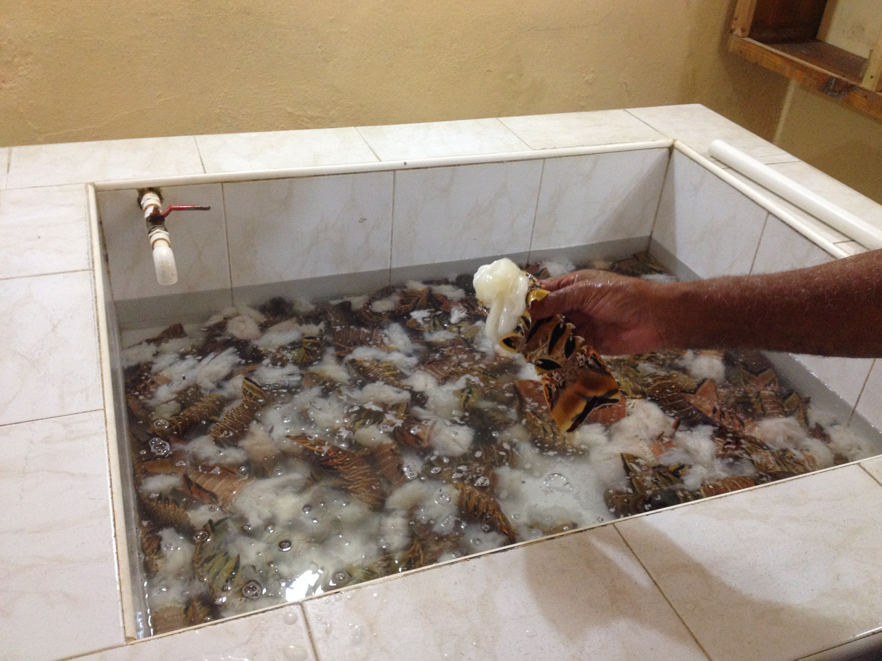
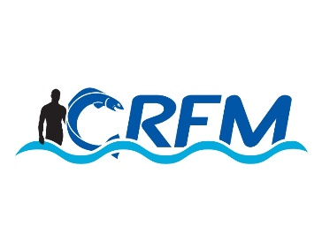


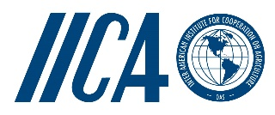
Project: Technical support to develop model legislation, protocols, guidelines for health and food safety related to fisheries and aquaculture in CARIFORUM States
Funded by the European Union
Managed by the International Institute for Cooperation in Agriculture (IICA) and the Caribbean Regional Fisheries Mechanism (CRFM)
June 2015

Haiti

Mission Report
+

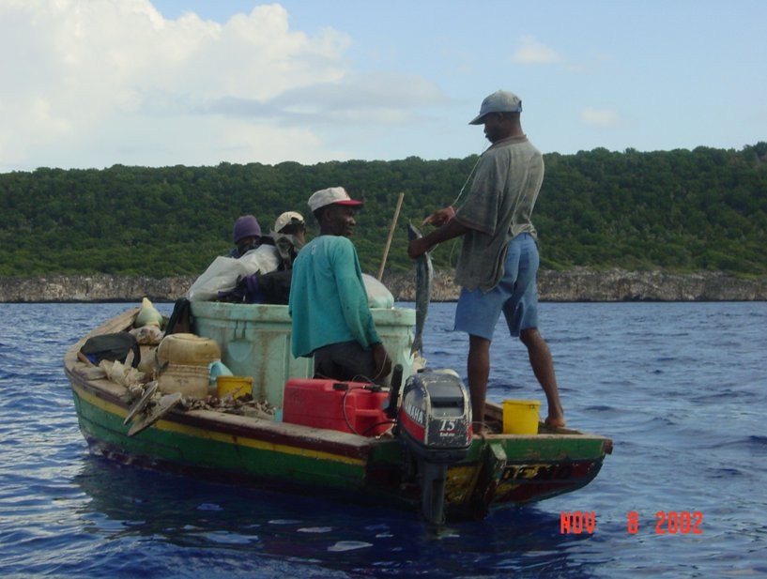
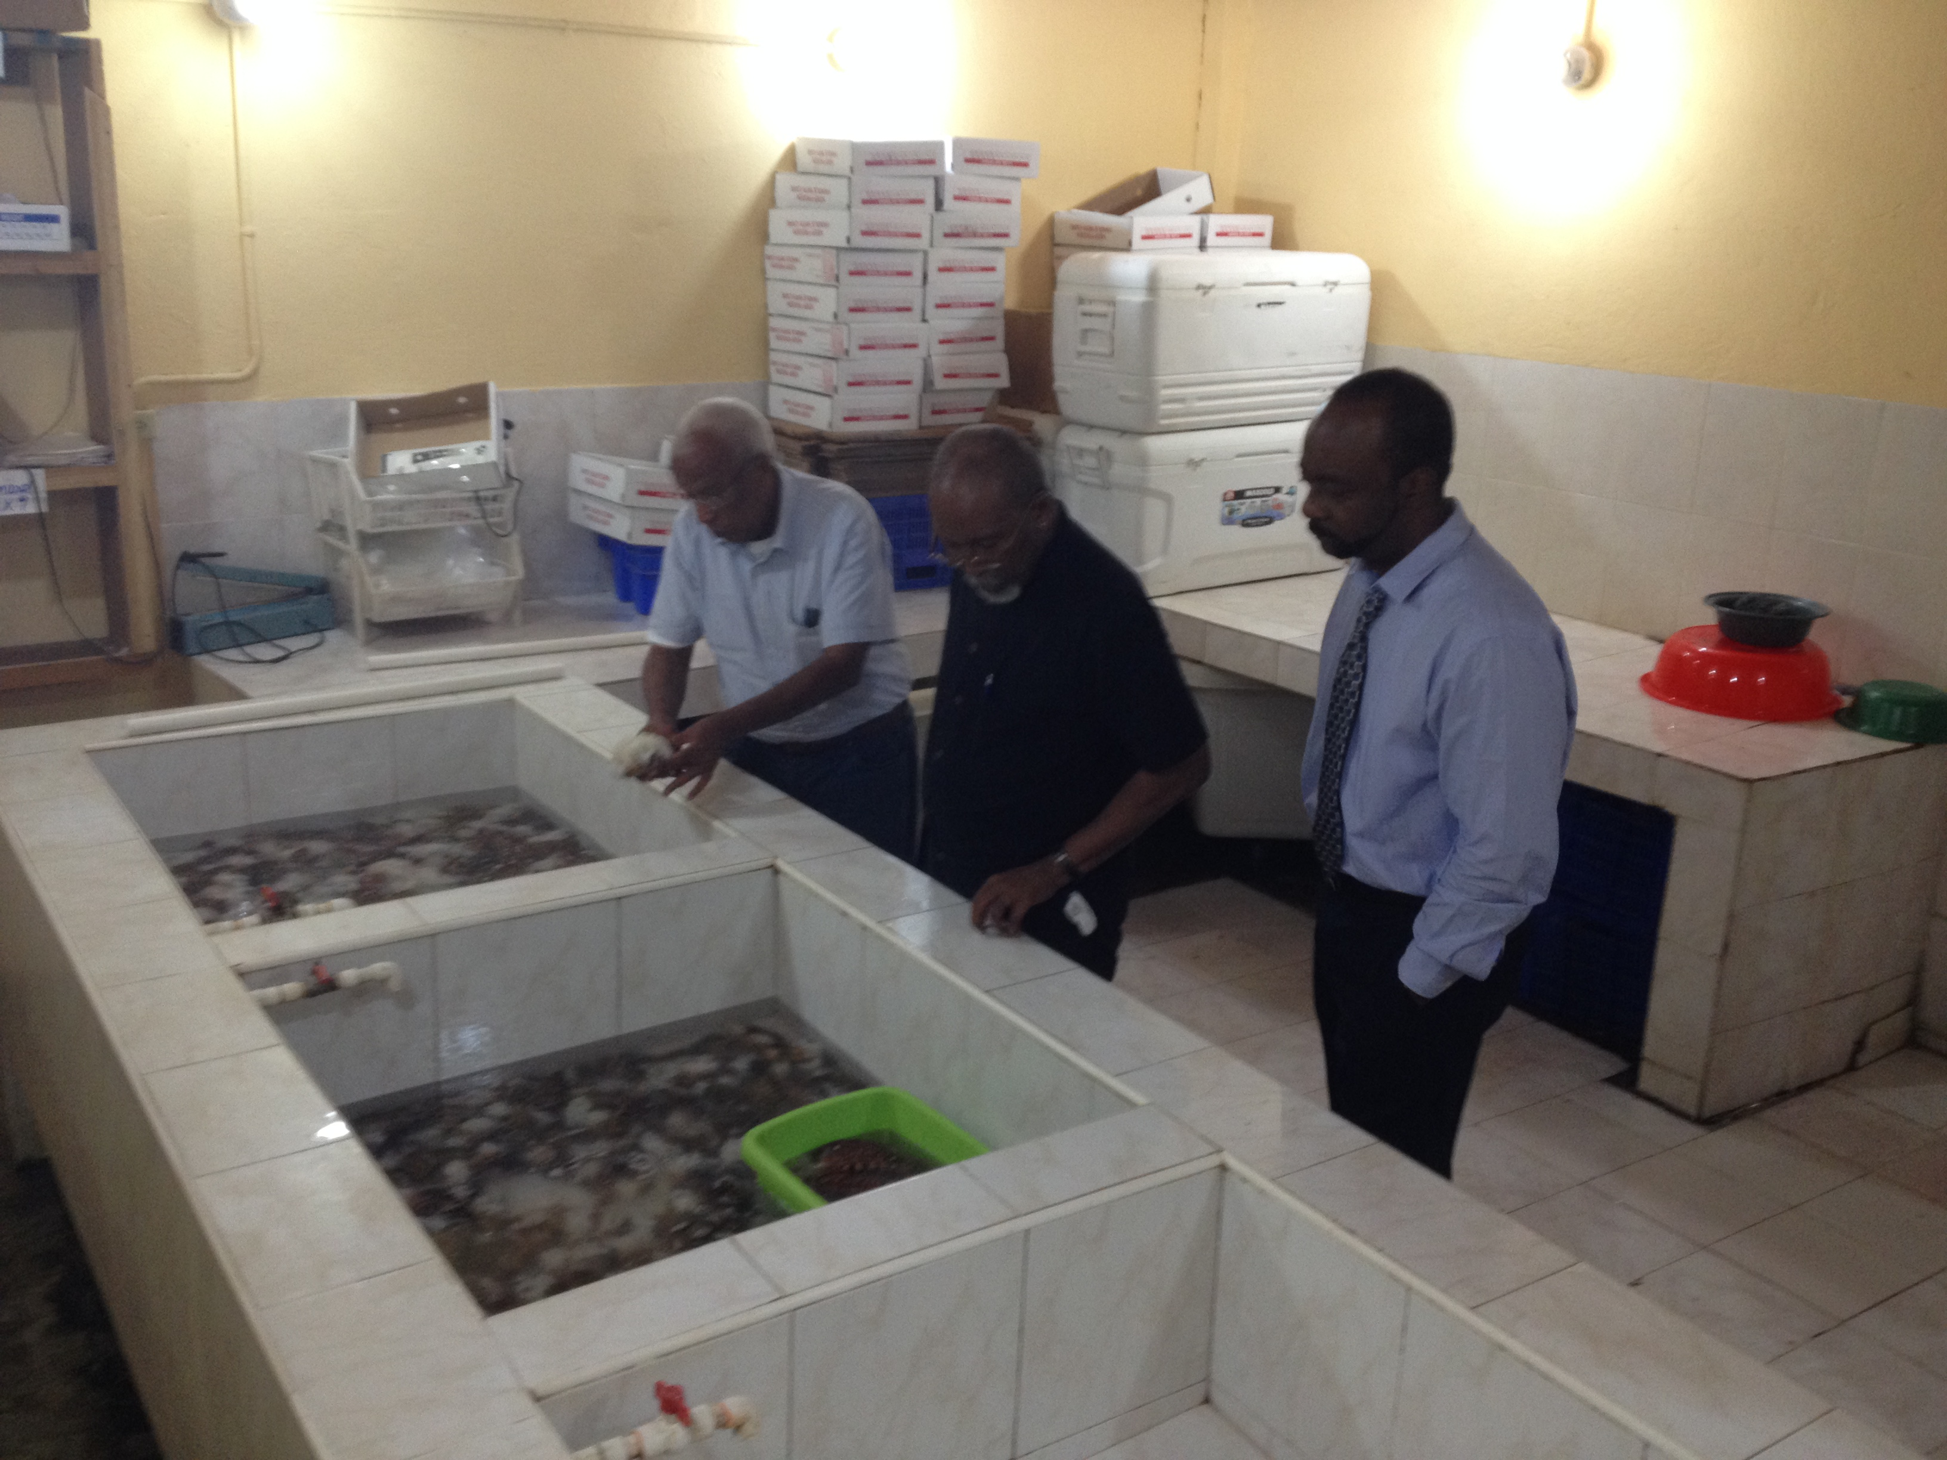

Contents

Mission Summary 2
Meeting Notes 2
Appendix | Document Lists Error! Bookmark not defined.

Mission Summary
- A mission to Haiti took place from 7-9 May. The mission team comprised the Project Team Leader (Chris Hedley), the SPS Expert (George Grant) and CRFM Programme Manager (Peter Murray).
- The following meetings and visits were organised:
- Meeting with Director of Fisheries
- Visit to processing plants (Caribbean seafood and La Filiere Congelee )
- National Consultation

Meeting Notes

Fisheries Division
A meeting took place in the Fisheries Division, with the Director of Fisheries, Mr Jean Robert Badio. Lengthy discussions took place, and Mr Badio gave a detailed presentation of the fisheries sector in Haiti and some of the issues facing it. Highlights of this presentation included:

- Haiti has a huge but disorganized fishing industry
- Fish Industry crucial to country in terms of food security and employment ;
- Fishing operations primarily artisanal in nature;
- The industry ‘s fishing grounds divided into eight (8 ) Regions;
- There were over fifty thousand (50,000) fisher folks in some 21 associations and utilizing hundreds (5-6,000) of artisanal-type (canoes) fishing vessels;
- The country currently produces approx.50,000 tonnes of marine and some 25,000 tonnes aquaculture products annually ;
- Exports fishery products to the USA and Japan mainly ;
- Exports go via Dominican Republic;
- Country not currently EU- approved (Exported to the EU up until to 1989);
- Sea cumbers ,lobsters and migratory species exported`;
- Conch export restrictions by CITES ;
- Aquaculture production being stressed for small scale fishers;
- Recently updated draft Fisheries Act;
- No fish health or laboratory support programme (new lab built but not operational);
- Catch size/fish size deterioration noted ;
- Dire need for fisher folk training but problem with resistance to change due to in grained culture;
- Infrastructural limitations;
- Organizational. legislative and SPS systems lacking in implementation and monitoring capacities
- inadequate monitoring systems / surveillance systems;
- Export of conch banned etc due to non compliance with CITES regulations;
- An estimated 40%of products under go spoilage due to post-harvest mishandling.

Site visits
The team members were taken on site visits to the Caribbean Seafood and La Filliere Congelee facilities located in Port Au Prince. The facilities were sound, but some way from being able to meet EU requirements, reflecting the level of investment and capacity-building required in the private sector. There was interest in developing future exports to the EU, but at the same time recognition that substantial additional support would be required for the sector.

National Consultation
Kinam Hotel, May 8, 2015
Opening Remarks
Welcome - Jean Robert Badio, Director of Fisheries and Aquaculture, Fisheries Department
- Briefly described/outlined reason of current activity
Remarks - Dr. Michel Chancy, Secretary of State for Animal Production, Ministry of Agriculture, Natural Resources and Rural Development

Remarks - Peter A. Murray, PM FMD, CRFM Secretariat
Protocol: Dr. Michel Chancy, Secretary of State
  - Mr. Alfredo Mena Pantaleón
  - Jean Robert Badio, Director of Fisheries
  - Dr. Max Millien
  - Rep of USDA
  - Reps of Stakeholders
  - Reps of the Media
  - Hopefully at the end of today, can say “Friends”

- Thanked participants for coming
- Greetings from ED and DED
- Noted importance of Fisheries Sector
  - Notes it potential for creation of wealth
  - This implies consideration of the value chain approach
  - Makes the issue of sanitary standards in turn, central to the expansion of the contribution sector to national economies
- This project is supported by the European Union and Implemented by IICA
  - Fisheries Components coordinated by CRFM Secretariat
  - This particular consultancy seeks to provide guidelines that you can help determine by your contribution to the discussions today

Introduction of the SPS Project and Present activities (C. Hedley and G. Grant)
- Overall objective; purpose; results to be achieved, outputs
- Snapshot of fisheries sector in Haiti
  - Families supported
  - Secondary employment
  - Overall production
    - Capture fisheries
    - Small beginnings of aquacultuure
  - Exports amount and value
  - Hope to understand from participants what are Visions for sector
    - ? Develop aquaculture
    - ? increase marine production
      - ? Amount?
    - ? meet local demand & reduce need for imports
    - ? Develop exports
- Why are we doing this?
- Where project fits in with overall need to improve food safety in fisheries
  - Accessing international markets – EU example
- Intervention from the flood: we know all this what we need is for someone to come and sit with us at our facility and tell us what we need to do to export
- Explained that this activity seeks to get exactly that type of intervention that can guide the process
- Comment: need to get access to credit
- Challenges related to Main SPS programme activities
  - The world is more food safety-conscious
  - Technical expertise and physical capacity
  - Management woes
  - Environmental concerns
- Emphasised that notwithstanding short-term notes, if long-term goals are to be met there is need for in-country framework
  - Consultancy seeks to assist in developing this framework
- Approach to consultancy including anticipated timeline
  - Consultative process (as for Jamaica)
  - Key actions with timetable (As for Jamaica)
  - Meeting objectives
    - Issues/ concern/needs in Haiti
    - Challenges in selling fish locally or internationally
    - What support is needed
    - What are ambitions
- Comment (Toussaint - coordinator sanitary protection unit): Important to have coordination of SPS activities to reduce duplication, while you are talking about capacity in ACP, in a few weeks (18 May) a workshop on this subject is planned with technical and financial support from USDA. Ask for representatives from private sector to attend.
Power point presentation on Lobster Fisheries in Haiti (Jean Robert Badio)
See PowerPoint presentation

Power point presentation on Sanitary .
See PowerPoint presentation
The presentations generated spirited discussions as to the serious challenges and issues facing the country and a possible way forward. Haiti’s inability to be in compliance with acceptable minimum acceptable standards of food safety was re-emphasized by some participants .There was a general eagerness for the country to find a way forward to achieve the desired levels of compliance to stimulate trading activities .
The final component of this consultation dealt with an over view and summarization of Haiti’s current SPS status aimed at pointing to the way forward.
The major finding could be summarized as follows:
- Limited financial resources;
- Limited human resource capabilities;
- Inadequacy of laboratory support system;
- Infrastructural deficiencies;
- No verifiable and or validated food safety system implemented;
- Weak Legislative underpinning;
- Un -organized artisanal fishery;
- Non documentation of current systems in place;
- Training at all levels of operation urgently needed;
- SPS focus to be on training, establishment of appropriate legislative frame work ,private /public sector cooperation .

