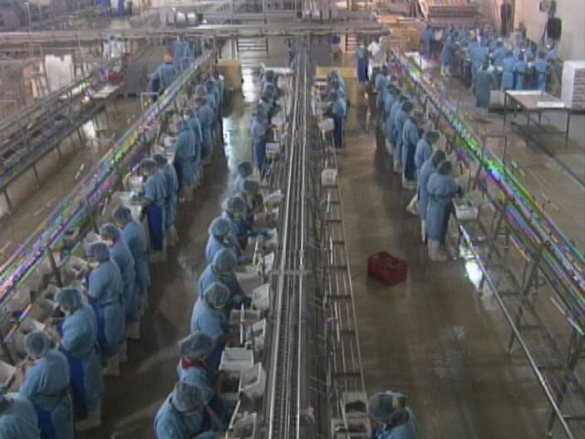

Belize

Mission Report
+

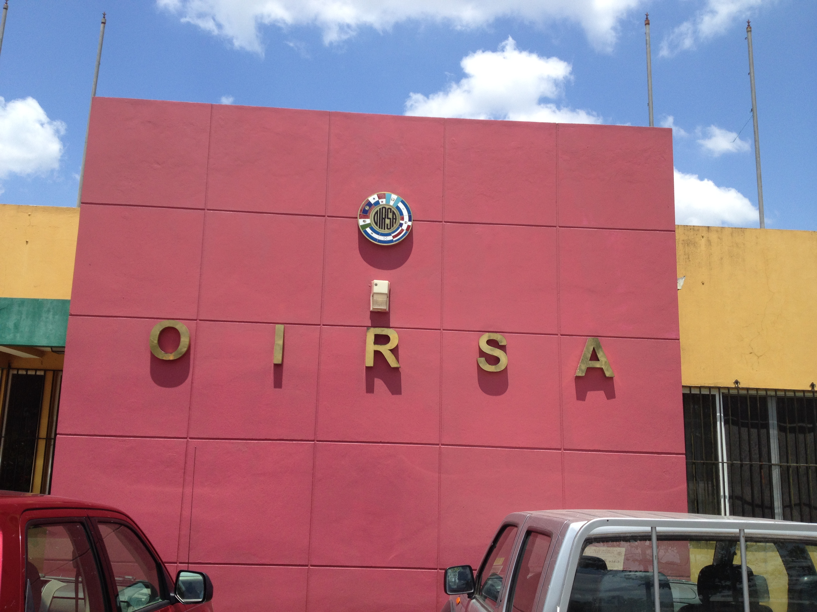
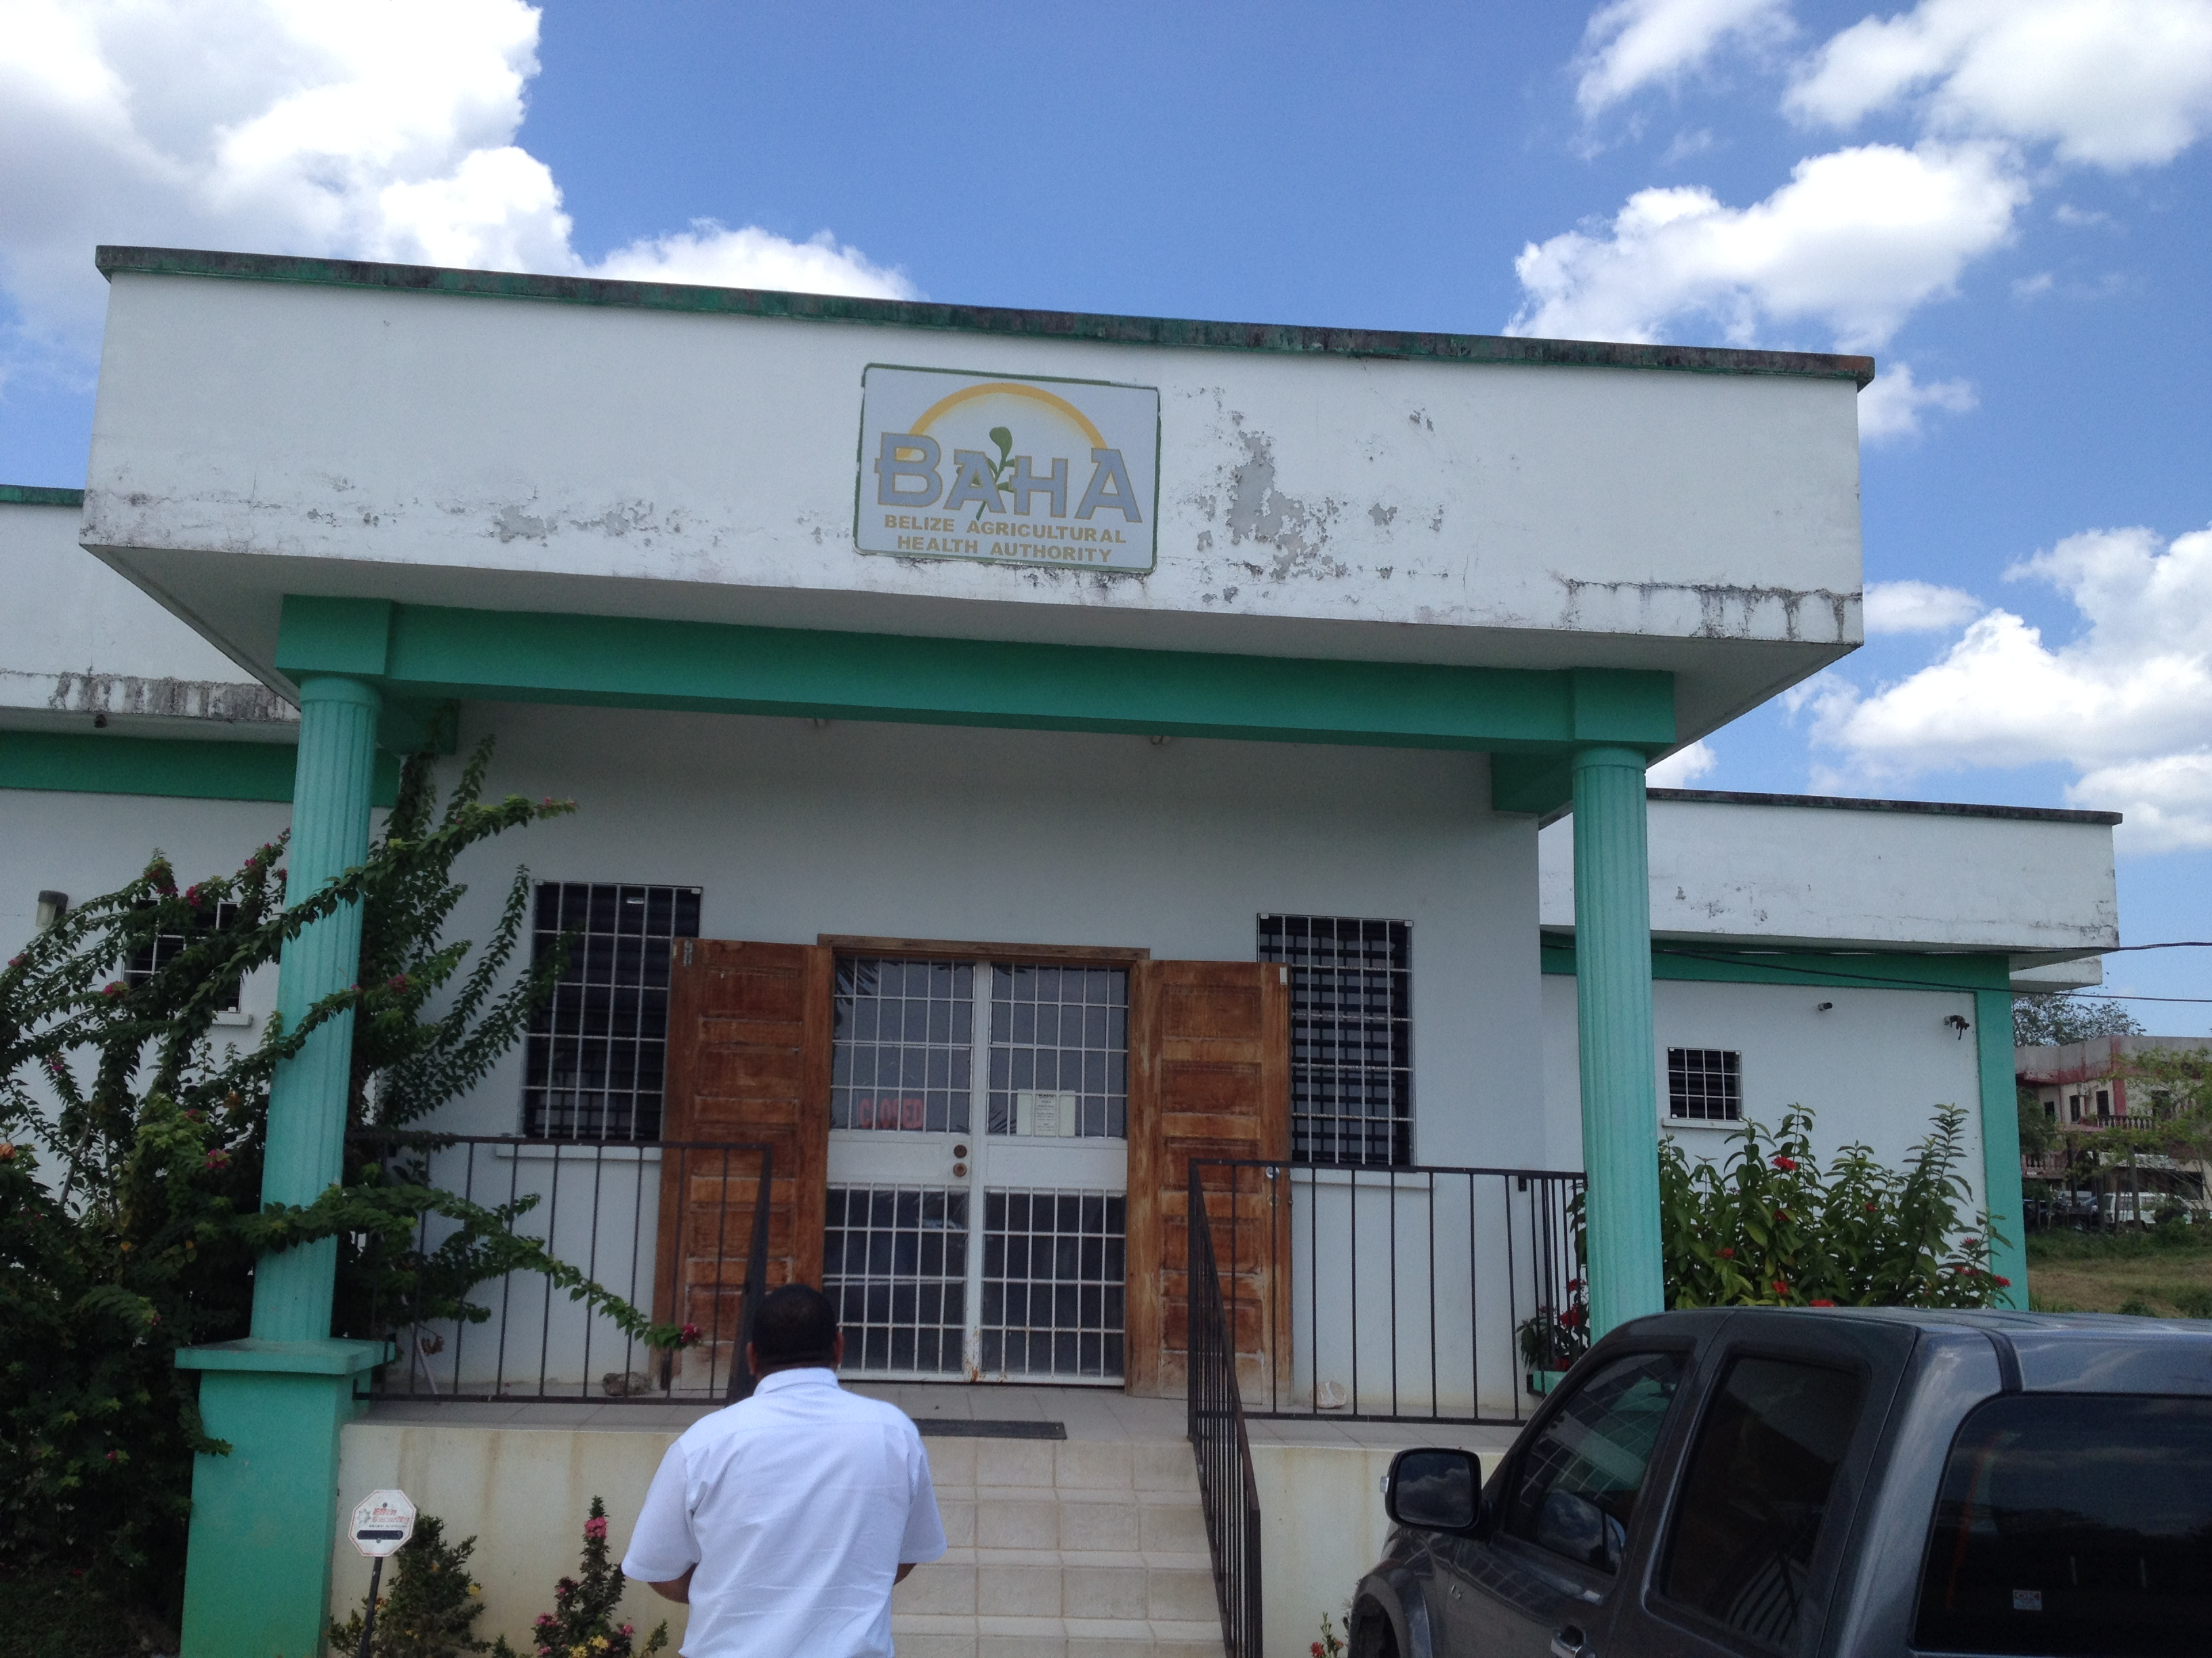
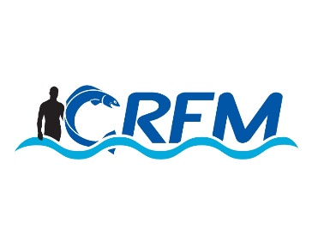



Project: Technical support to develop model legislation, protocols, guidelines for health and food safety related to fisheries and aquaculture in CARIFORUM States
Funded by the European Union
Managed by the International Institute for Cooperation in Agriculture (IICA) and the Caribbean Regional Fisheries Mechanism (CRFM)
June 2015

Contents

Mission Summary 2
Meeting Reports 2
Appendix | Document Lists 9

Mission Summary
- A mission to Belize took place on 4 and 5 May. The mission team comprised the Project Team Leader (Chris Hedley) and CRFM Programme Manager (Peter Murray).
- The following meetings and visits were organised:
- Briefing Session with CRFM / Fisheries Department
- Field visit to Fein Catch Tilapia Farm – Mr. Roberto Salas – Farm Manager
- Meeting with Country Representative - International Regional Organization for Plant and Animal Health (OIRSA) (Mr. Fermin Blanco)
- Meeting with Director of the Belize Agricultural Health Authority & Senior Staff (Mr. Emir Cruz – Managing Director – BAHA, Mrs. Delilah Cabb Ayala – Coordinator: Sanitary & Phytosanitary Enquiry Point - BAHA)
- Meeting with the Ministry for Foreign Trade – (Ms. Margaret Ventura & Mr. Richard Reid)
- Meeting with Drafting Unit of the Solicitor General’s Office (Mr. Randall Sheppard).
- A well-attended National Consultation was organized on 5 May.

Meeting Reports

Briefing Session with CRFM / Fisheries Department
A brief meeting took place with the Fisheries Department, mainly to discuss logistical requirements for the mission. Mr Rigoberto Quintana was tasked with organization the mission, and liaising with the project team.

Field visit to Fein Catch Tilapia Farm – Mr. Roberto Salas – Farm Manager
A brief meeting took place with the Fisheries Department, mainly to discuss logistical requirements for the mission. Mr Rigoberto Quintana was tasked with organization the mission, and liaising with the project team.

International Regional Organization for Plant and Animal Health (OIRSA)
A helpful meeting took place with Mr. Fermin Blanco, Belize Country Representative for OIRSA. A presentation of the activities and actions taken by OIRSA was provided. Of particular note were:
- OIRSA provided certain technical services to its members (certain due diligience and inspection services concerning veterinary tests). For this, a fee was charged and any surplus funds were directed to in-country projects. This was win-win, because OIRSA was able to provide the services more effectively and cost-efficiently than individual Member States, while at the same time it was a means to divert funds back into country projects. The potential of implementing similar approaches in Caricom was discussed, although it was noted developing common frameworks in Caricom was a more complex and lengthy process than in SICA.
- It was also explained that OIRSA played a significant role in supporting international negotiations and meetings. Due to limited financial, human and technical capacities of Member States, and the large numbers of meetings involved in the food and SPS sector, meetings were sometimes “shared” amongst the Member States and OIRSA. Typcially, a Member State would be selected to represent the Member States collectively, and would be supported by OIRSA technical staff. This gave the delegation more technical expertise than it might otherwise have (and enable the Member States to deal with other technically-equipped delegations, such as those from the EU, USA, etc.). Also, it enabled a wider coverage of meetings, since the expense of sending individual delegations was reduced. It could sometimes be difficult to reach agreement on the approach, however.
- A number of technical activities carried out by OIRSA were also discussed, including the provision of technical manuals and guides and harmonised procedures.

Belize Agricultural Health Authority (BAHA)

Attending:
Mr. Emir Cruz, Managing Director (Email: emir.cruz@baha.org.bz)
Dr. Miguel Figueroa - Director, Food Safety (Email: miguel.figueroa@baha.org.bz )
Dr. Miguel Depaz, Director, Animal Health (Email: miguel.depaz@baha.org.bz)
Mr. Margarito Garcia, Quarantine (Email: margar.garcia@baha.bz.org)
Dr. Natalie Gibson, Deputy Director/Laboratory Administrator, Food Safety (Email: natalie.gibson@baha.org.bz)
Mr. Endhir Sosa, Senior Food Safety Inspector, Food Safety (Email: endhir.sosa@baha.org.bz)
Ms Delilah Cabb Ayala, Coordinator, SPS Enquiry Point (Email: bahasps@btl.net or delilahcabb.ayala@baha.org.bz)

Ministry of Foreign Trade

A meeting took place with Ms. Margaret Ventura & Mr. Richard Reid, policy officers n the Ministry responsible for EU Economic Partnership Agreements. Ms Ventura considered that fisheries SPS issues were essential as part of the overall EPA relationship, but that they were not highly visible in her office. There needed to be better coordination on EPA issues – it was noted that the TNINT / National Committee was intended to fulfil this type of coordinating function, and that the Ministry should be included in the composition. It was also noted that the EPA, the EPA negotiations and the overall EU relationship had a role to play in supporting fisheries SPS. CH noted that the current project was only a first step – much more capacity building was required, and that would require funding. These needs should be made visible in the EPA relationship.

National Consultation
Belize Biltmore Plaza Hotel. May 5, 2015
Brief welcome remarks by George Myvett (Meeting Chair).
Opening Remarks – Mr. Milton Haughton – Executive Director, Caribbean Regional Fisheries Mechanism
- Thanked EU for support
- Used Iceland as an example of the use of value chain approach to fisheries as a generator of wealth
- Noted the adoption of CCCFP and its long-term objectives
- Noted the importance of SPS for local consumption and from global perspective
- Outlined specific objectives of the wider project
- Noted that this is an important project if we are to meet the objective of creating wealth. SPS issues can be a major constraint if not up to standard since international trade is a very important aspect of fisheries development.
- Thanked participants for coming and look forward to vibrant discussions
Presentations
BAHA’s Perspective on Current SPS Measures and On-going Initiatives
Presented by Dr. Miguel Figueroa – Director, Food Safety Belize Agricultural Health Authority (see presentation)
Biosecurity Legislative Framework for Belize
- Enabling legislation drafted in 1994
- Belize became a member of WTO 1995
- Act enacted in 1999
- First Review conducted in 2003 by Dr. Black (CanEd Consultations)
- Food Safety Regulations-updated version 2014
  - Food Safety Regulations SI no. 25 of 2001
  - Food Processing Plants (potable water) (Minimum Standards) Regulations SI no 24 of 2001
  - Biological Residues Control Regulations SI 183 of 2001
  - Fish and Fisheries Product (Inspection) Regulations SI no 173 of 2001
- Fish and Fisheries product Inspection Regulations
  - Part I: Citation, Interpretations
  - Part II: Import of Fishery Products; lays the requirements for import permit
  - Part III: Requirements for fishery products: section 8 requirements for compliance with food safety conditions and section 9 requirements for annual approval of a fish processing establishment, freezer vessel or factory vessel.
  - Part IV: Control on Fishery products. Section 13 performance of inspections and checks and certification.
- Fish and Fisheries product Regs
  - Schedule 1: Requirements for fishing vessels- Design and construction and hygiene requirements on board fishing vessels
  - Schedule 2: Requirements for freezer and factory vessels-Design and construction.
  - Schedule 3: Requirements for establishments-design and construction and hygiene requirements
  - Schedule 4: Transport of fishery products.
  - Schedule 5: Requirements for fishery products

- Schedule 5
  - A: Organoleptic properties
  - B: Total volatile Nitrogen
  - C: Parasites (visual inspection)
  - D: toxins (poisonous fish, ciguatoxins)
  - E: Environmental contaminants (Pb, Cd, Hg, Dioxins/PCBs
  - F: Microbiological standards (Lysteria, Salmonella, E. coli , Histamins etc.)
  - G: Additives
- Schedule 6
  - Sampling of Fishery Products.
Introduction of the Consultancy - Mr. Christopher Hedley – Team Leader
- Project background
- Component purposes
- Outputs
  - A “toolkit” or model documents package
  - Model CARIFORUM Guidelines on Sanitary Standards for fishery and aquaculture products
  - Model CARIFORUM Sanitary Standards for Fishery and Aquaculture
  - Model Export Control Act
  - Model Supplementary Regulations
  - Model Guidelines on Developing Coordinating Mechanisms for National and Regional Fisheries SPS Governance
- Why are we doing this?
  - Supporting and developing international trade
  - Promoting competitiveness
  - Ensuring / increasing market access
  - Improving national food safety
  - Supporting the fishing industry

- Indicative stakeholder map
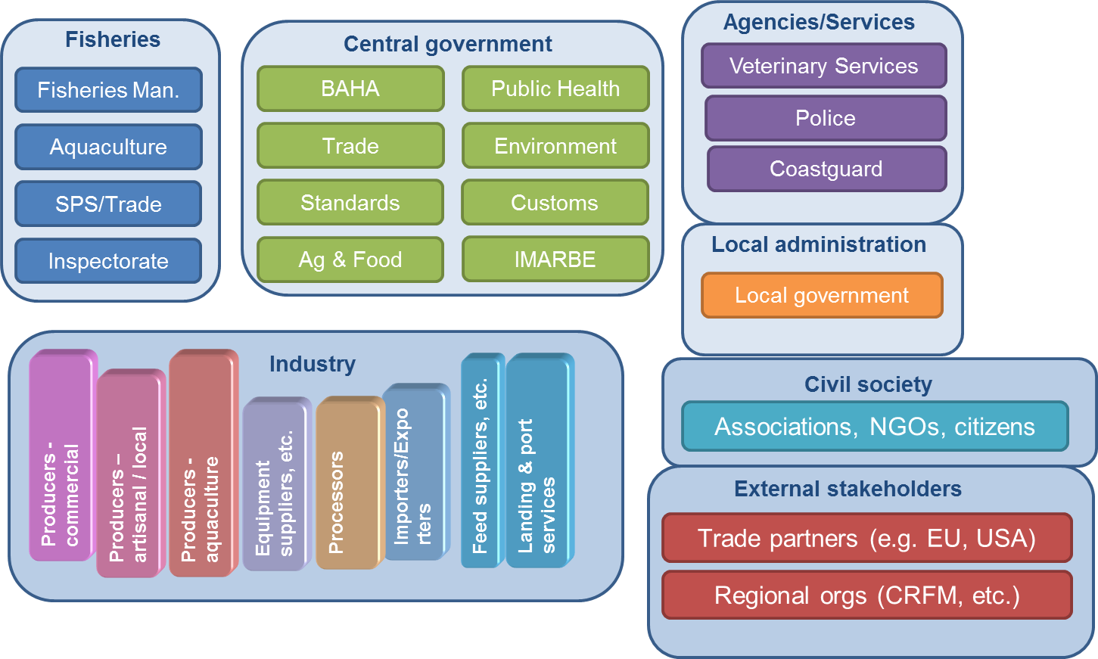

- Challenges related to Main SPS programme activities
- The world is more food safety-conscious
  - As efforts continue towards more trade within the CARIFORUM states at the international level, the fisheries sector faces more pressure from consumer and advocacy groups who continue to demand quality and healthy foods for human consumption.
- Technical expertise and physical capacity
  - In order to have effective and efficient systems for agricultural and fisheries health and food safety, there must be strong technical skills amongst fisheries employees and stakeholders, as well as the necessary physical infrastructural capability
- Management woes
  - In many CRFM states, the responsibility for managing SPS efforts is spread over a number of agencies. This lack of structure often leads to patchy standards that are harder to enforce and monitor for progress
- Environmental concerns
  - The biodiversity of the ecosystems in the region provide a rich source of income for many local fisher-folk; however, they are very fragile, often being severely affected by natural disasters such as hurricanes.

- Consultative Process
- Dialogue
  - Project Discussions
  - Stakeholder Meetings
  - National Workshops
- Development
  - Planning and Review
  - First Drafts
  - Internal Project Review
- Consultation
  - Dissemination: Regional Stakeholders
  - Review and Comment
  - Revision
- Validation
  - Regional Validation Workshop
  - Final Revisions
  - Handover / Signoff

- Key actions
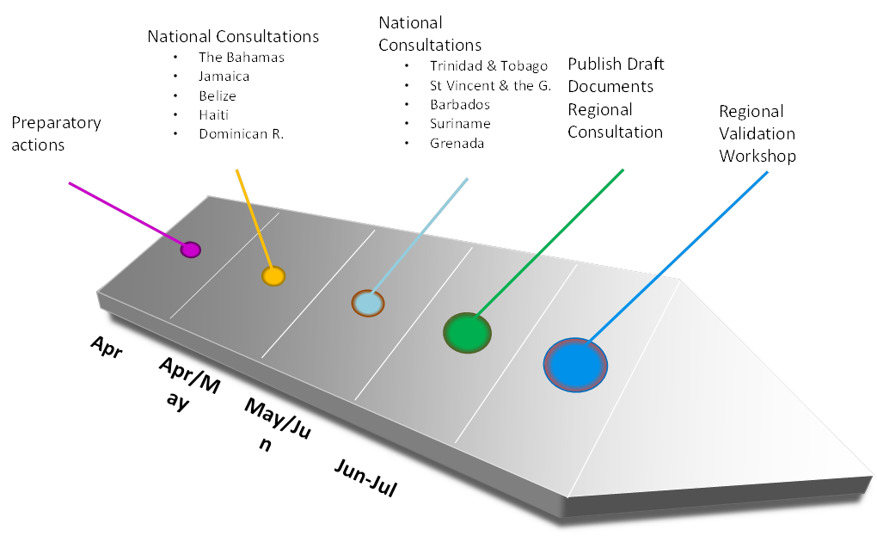
- Belize Mission
  - key activities: meetings with Fisheries Department, stakeholders, national consultation, document collection and review
  - Observations
    - new legislation close to completion – food safety/SPS and fisheries
    - many agencies – high level of competence
    - scope for closer coordination
    - some strong industry sectors
    - mindful of EU sanctions

Group Discussion: Stakeholder Inputs on the Process
Legislative and coordinating requirements for SPS in the Fisheries Sector
- Challenge of different standards accepted, from fishers/producers, by cooperatives especially as it relates to national legislation regarding legal sizes as compared to what is acceptable quality in the market
- Linkages between regulations on IUU fisheries and exportability of product to some markets (e.g. EU) need to be considered
- Belize exports are in keeping with requirements since local laws are consistent with EU guidelines/requirements (which are not always enunciated in their regulations).
- Standards related to fishing vessels may be considered for management/coordination at the regional level, especially in the context of US’ Food Safety Modernisation Act (FSMA).
- Note that fish has been “ahead of the game” with a number of these requirements and so FSMA does not really affect the fisheries sector, at this time, since most of the issues under FSMA have already been covered in relation to the sector.
- Traceability issues need to be given more consideration
- Consider regional working group of fisheries (export) associations/cooperatives to discuss issues related to SPS and food safety issues in the fisheries sector.
- Need to consider/deal with the realities of non-compliance; also penalties for same.

Closing Remarks – Mr. Peter A. Murray – Programme Manager, Fisheries Management and Development, CRFM Secretariat
- Thanked people for coming
- Recalled words of ED regarding wealth generation and
- Pointed to Environmental Monitoring Consultancy, upcoming around 19th May
- Invited all to lunch

Meeting with Solicitor General’s Office
A brief meeting took place with Mr Randall Sheppard, Legislative Drafting Officer (Drafting Unit, Solicitor General’s Office). The current state of play of draft Bills in the SPS sector were discussed, and the process for developing and applying regional legislation. The proposed approach, as presented in the National Consultation, was considered a good one.

