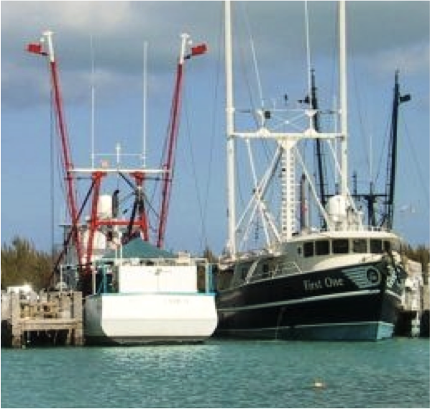
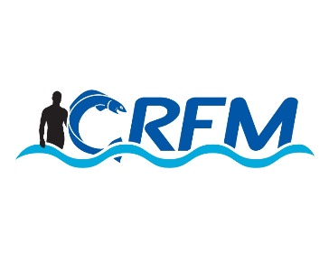
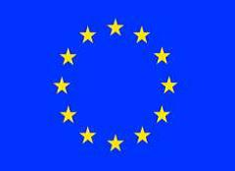


Project: Technical support to develop model legislation, protocols, guidelines for health and food safety related to fisheries and aquaculture in CARIFORUM States
Funded by the European Union
Managed by the International Institute for Cooperation in Agriculture (IICA) and the Caribbean Regional Fisheries Mechanism (CRFM)
June 2015

The Bahamas

Mission Report
+
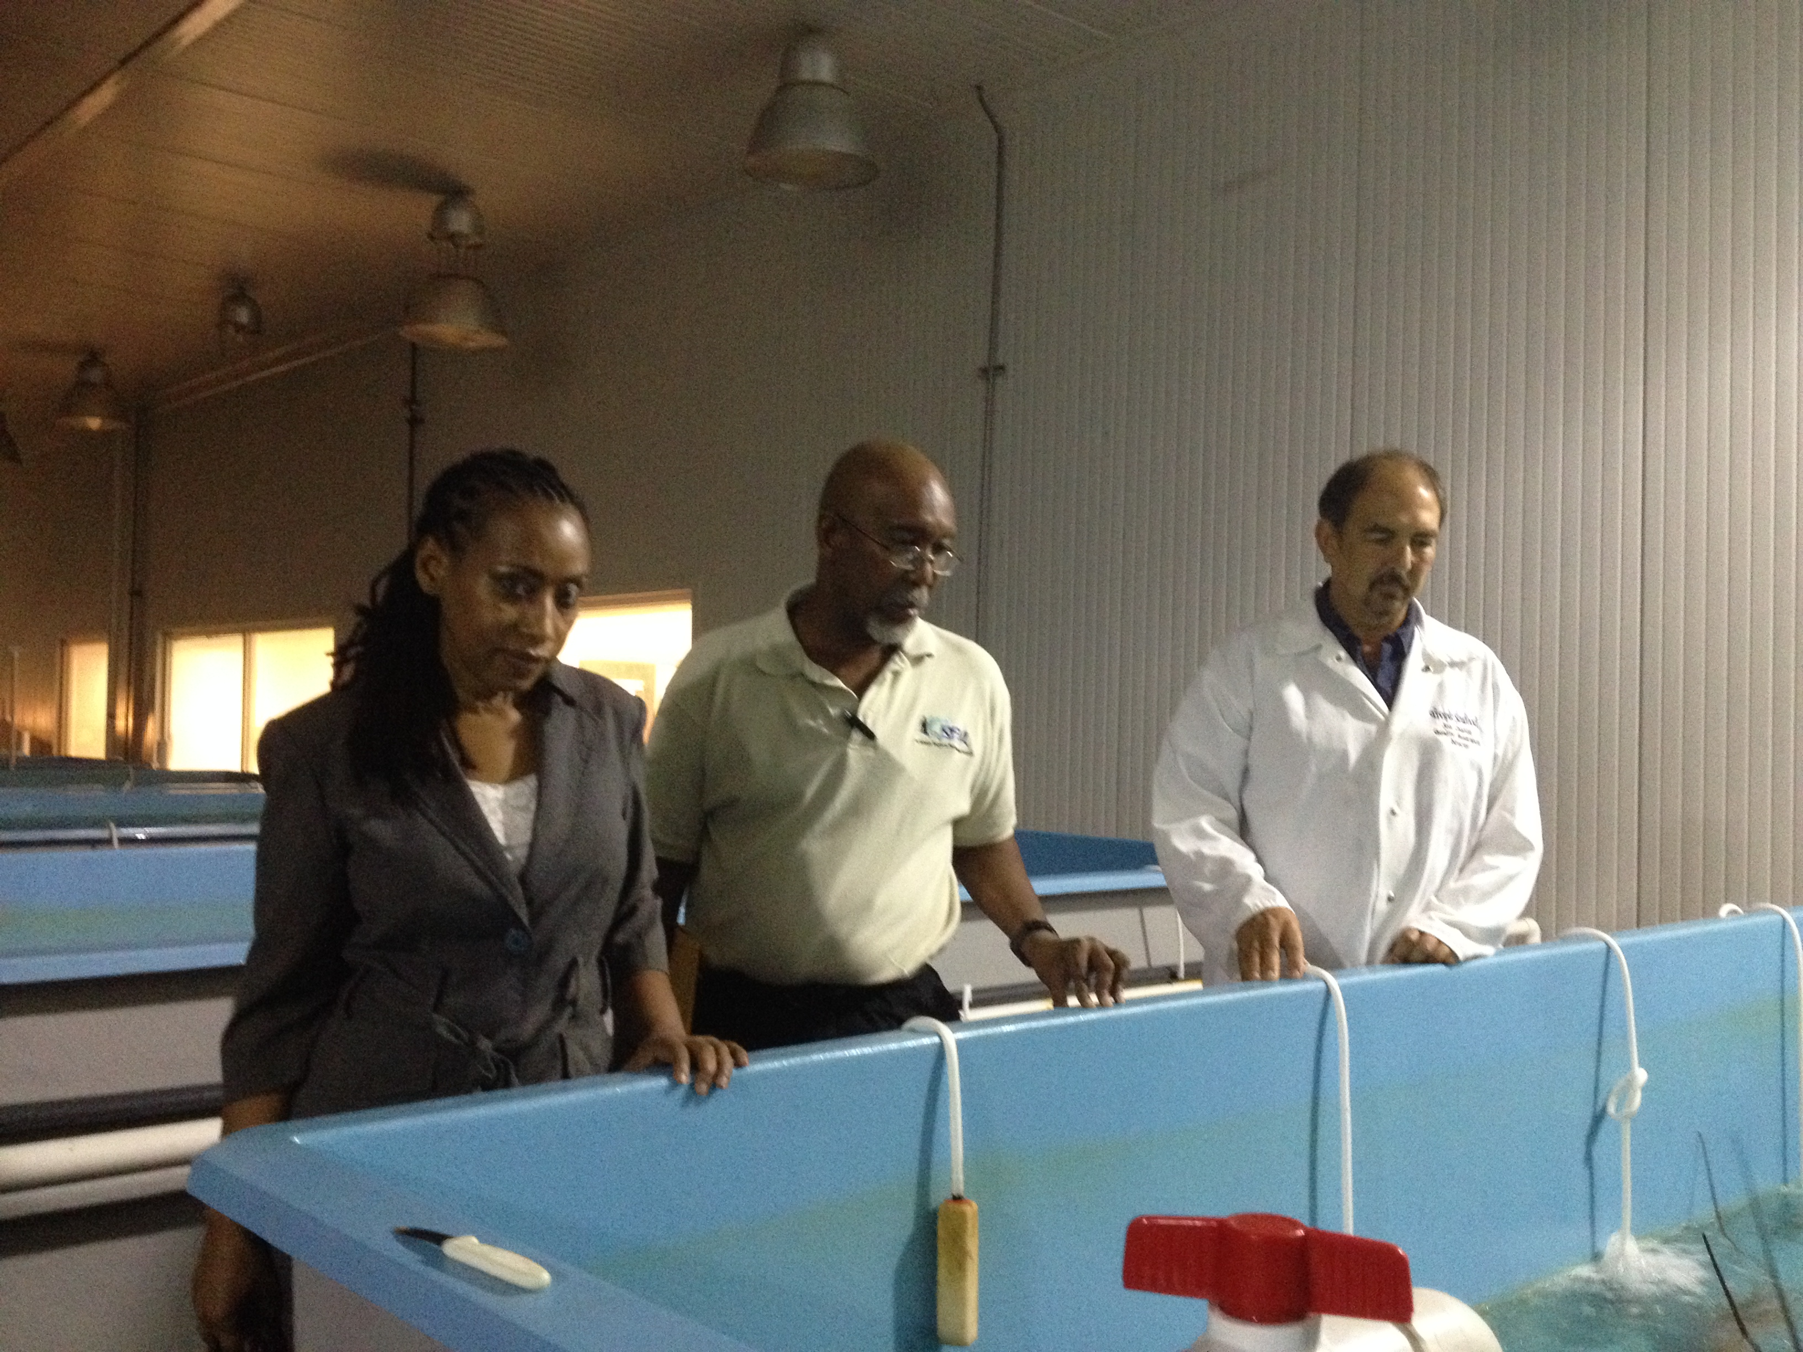

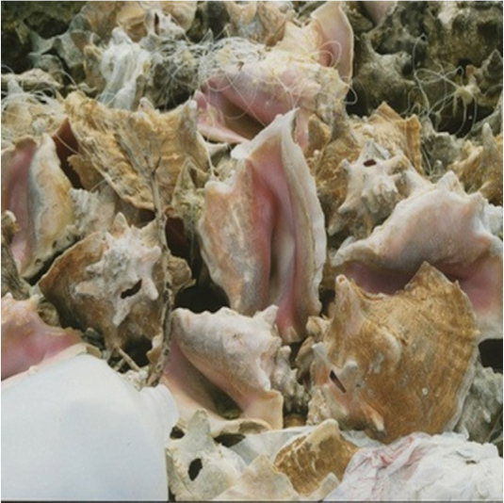

Contents

Mission Summary 2
Meeting Notes 2
Appendix | Document Lists 6

Mission Summary
- A mission to The Bahamas took place from 22-28 April. The mission team comprised the Project Team Leader (Chris Hedley) and CRFM Programme Manager (Peter Murray).
- The following meetings and visits were organised:
- Meeting with senior staff from the Department for Marine Resources
- Meeting with drafting lawyer from the Attorney-General’s Office (responsible for drafting new SPS Bills)
- Meeting with the national SPS Committee (in effect, the TNINT), comprising representatives from BAIC, IICA, EH, BMEA, DoA, Agriculture Producers groups (this meeting formed the national consultative workshop – see below).
- Visit to a key production establishment - Tropical Seafood.
- Due to the short-notice of the mission, it was not possible to organize meetings with other stakeholders but the mission team was nevertheless able to get a good understanding and appreciation of the national context.

Meeting Notes

Fisheries Division
Introduction of mission team and FD staff (MB)
- Present were:
Michael Braynen - Director
Edison Deleveaux - Deputy Director
Gregory Bethel - Senior Economist, Fisheries Department
Roland Allbury - Senior Fisheries Officer
Gilford Lloyd - Senior Fisheries Officer
Greg Cartwright - Fisheries Superintendent
Pat Bethel - Consultant
Brickell Pinder - Senior Economist, Ministry of Agriculture
Peter A. Murray - PM, FMD, CRFM
Chris Hedley - Legal Consultant

Introduction to the consultancy
- Project overview (PAM)
- Specific Consultancy overview (CH)
Key stakeholders and institutions to be “involved in the discussion” (garnered from discussions)
- Department of Agriculture
- Department of Environmental Health
- Department of Fisheries
- Bureau of Standards
  - has a role but is still fledgling under Finance
  - more a monitoring/advisory function than “executive”/management
- Technical aspects would be developed by relevant agency
- Bahamas Marine Exporters Association
- Bahamas Agricultural and Industrial Corporation
  - Possibly as relates to aquaculture (?) as users (?) and investment opportunities in the food production sector (at level of environmental monitoring and compliance in aquaculture)
- “Producer” associations
- Consumers (general public since there are no consumer groups/associations, per se
- Bahamas Agriculture and Marine Science Institute (BAMSI)
  - especially as relates to capacity building in the context of “from farm to fork” approach
Analysis of Ministry/ FD as a stakeholder group
- Current fisheries legislation speaks to SPS concerns from the time the fish is caught
- Under the Draft BAHFSA Bill, the BAHFSA can delegate responsibilities that are sectorally specific
- Currently only DoF and DoEH have any legislation related to HFS
- Draft Bahamas AHFS Authority bill speaks to a National SPS committee in which Fisheries is represented
Logistical Arrangements for meetings with key stakeholders and institutions (individual meetings/national consultation/ site visits/ etc.)
- Meeting with TNINT (has another name)
  - comprises reps from BAIC, IICA, EH, BMEA, DoA, Agriculture Producers groups
  - need to confirm whether it can be met on Monday during their regular meeting
  - meeting will be primarily introductory as they would be involved in one of their regular meetings
  - may meet specifics members afterwards (at “consultation”)
- Legal expert that was involved in drafting the bills supplied
  - 3:30 pm
- Meeting with key stakeholder (groups)/institutions
  - Monday
- Visit to Tropical Seafood
  - Visited before (09:35) current meeting and had discussions with President, Quality Assurance Director
  - viewed Aquaculture of Nassau grouper, aquaponics, vegetable greenhouse

- 1/2 day National Consultation
  - IICA office has indicated availability of their offices for the national consultation (Monday afternoon). Subsequently determined that Team will meet with the “TNINT” around 12 (after their regular meeting), providing lunch as an incentive to those who are willing to stay and from thence hold discussions as would have been anticipated for the consultation

Tropical Seafood

- A meeting with staff and tour of the facility at Tropical Seafood was organised. Discussions took place with the company President and the Quality Assurance Director. Both stakeholders considred that it was a constant challenge to meet the export requirements of trading countries. However, they considered that beyond that

- A tour of the facility was organized, and the project team viewed aquaculture of Nassau grouper, aquaponics and vegetable greenhouses. The potential for diversification from fish products was under consideration.

TNINT/National Consultation

Opening remarks
- Introduction of team by Michael Braynen
Introduction of participants
Participants introduced themselves and identified their organisations. They comprised the TNINT (a.k.a SPS Committee) plus other invitees and represented the following agencies/organisations (see attendance sheet):

- BAIC
- BAMSI
- DMR
- Vet
- Dept of Agric
- College of Bahamas
- Food safety of DMR
- Marketing (Min Agic)
- IICA
Introduction to the project & present activity
- Introduction to the Project and the consultancy by Chris Hedley
  - Overview of Project (PowerPoint presentation available from C. Hedley under separate cover)
    - ToRs for consultancy (overall objective; purpose; results to be achieved, outputs)
    - Approach to consultancy including anticipated timeline
    - Topics for current discussion: “Thoughts on legislative and coordinating requirements”
    - Issues/challenges and related Main SPS programme activities
Lunch Break
Thoughts on legislative and coordinating requirements
- SPS as it relates to invasive species (e.g. Lionfish) and/or pollution especially in the case of migratory/shared species needs to be given some consideration
- Issues related to environmental monitoring for SPS need to be considered and incorporated into model legislation
- Legislation
  - Existing and proposed national legislation
    - assume that draft and existing legislation in Bahamas are pertinent
    - need to consider how enforcement personnel/expertise can be allocated /disposed among the relevant agencies and how issues can be dealt with under specific legislation
  - Regional legislation/requirements/protocols of relevance to The Bahamas
    - Regional support needed with regard to poaching (and the implications for food safety)
    - Inspection at sea becomes a concern that may have to be dealt with through regional collaboration (e.g. regional inspectorate)
    - Conditions/protocols related to recall need to be considered
    - (Fisheries) Waste management and sanitation impacts on SPS requirements (may be considered under the rubric of environmental monitoring/management?)
    - SPS may need to be incorporated in greater detail in the FPM and SOPM. Manuals would need to be developed that provide the basis in law for SOP with regard to SPS
    - Importance of inter-agency cooperation; this also relates to monitoring of SPS conditions at community (?) and other food worker level
      - This begs the question of the need for standards (voluntary or government certified)
Roles and relations of institutions and stakeholder groups for SPS coordination
- Draft legislation (11 Feb 2015) satisfactorily speak to the roles and responsibilities –
  - Authority should have a coordinating role with responsibilities farmed out to different agencies. Consideration may need to be given to whether the Authority will be given the resources to carry out full responsibility
    - Consideration for interagency commitments (maybe thru MoUs?) in keeping with implementation
    - Legislation is a framework and there would/might be need for regulations hat determine how the process takes place
Way forward and close
- There was no formal discussion on the way forward since this had been captured in the overview of the project (timeline)

Appendix | Document Lists

Documents Collected
- Food Safety and Quality Bill, 2015
- Animal Health and Production Bill, 2015
- Agricultural Health and Food Safety Authority Bill, 2015
- Food Act 1985
- Food (Seafood Processing and Inspection) Regulations 2002

Media Coverage
- None

Presentations
- Project Overview, Chris Hedley

Photographs
- Visit to Tropical Seafood

