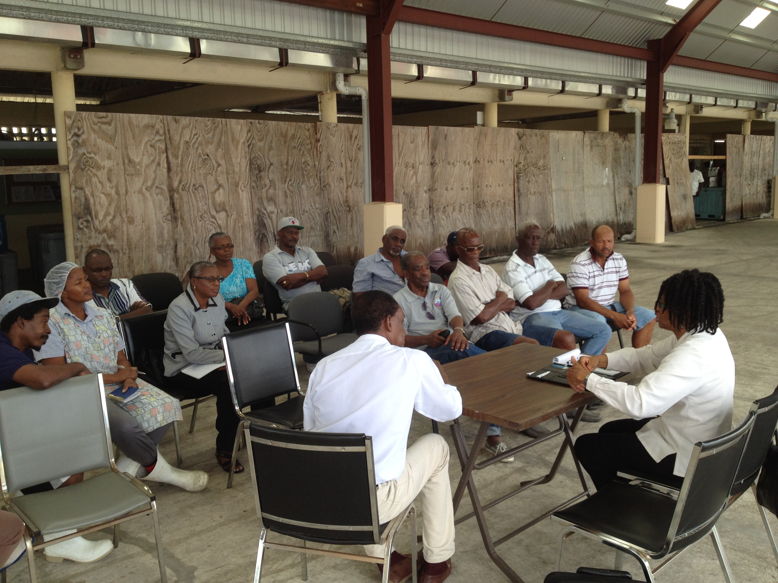
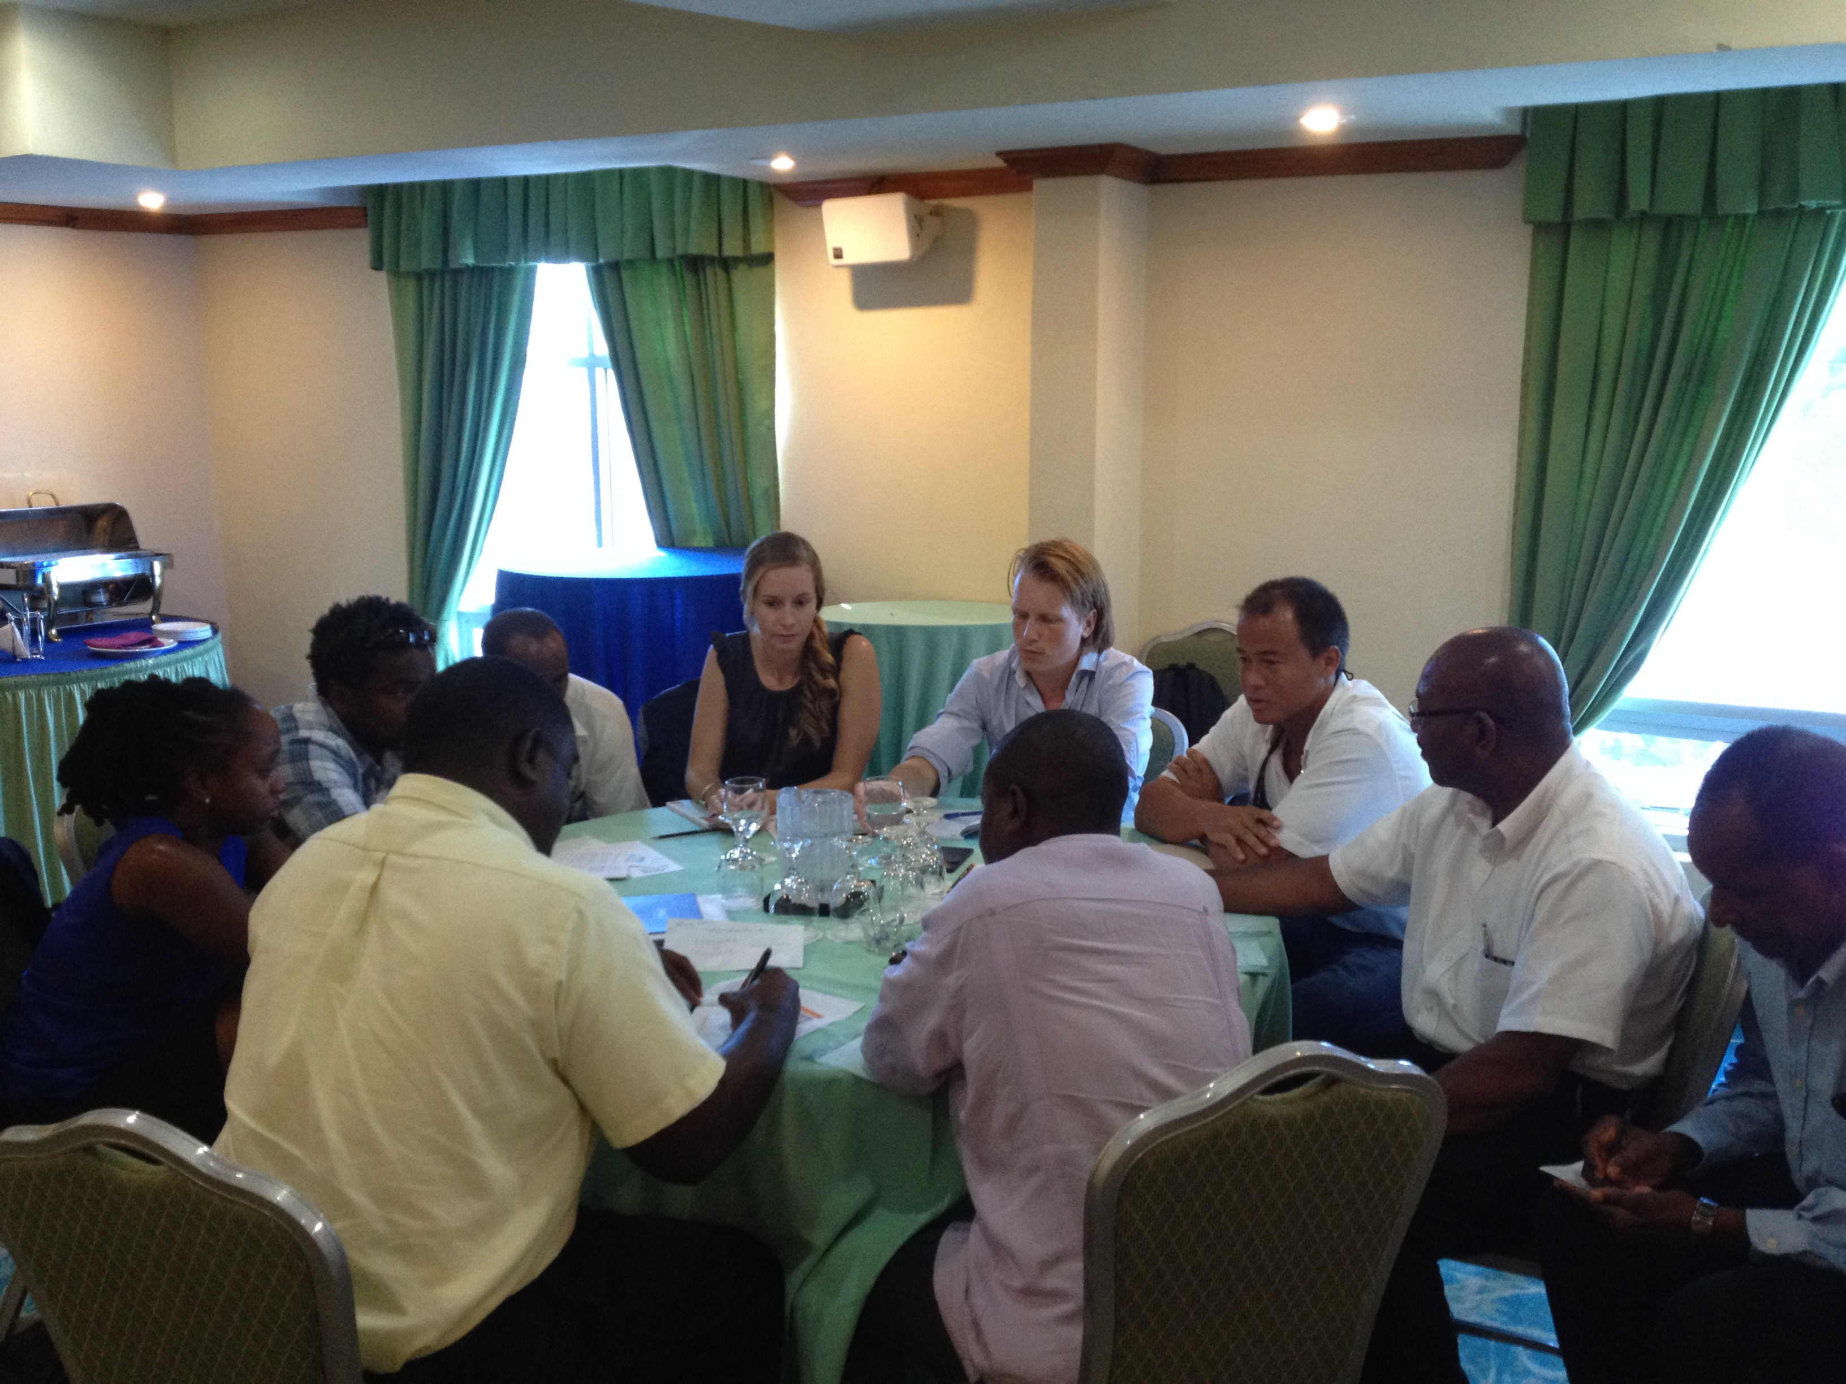
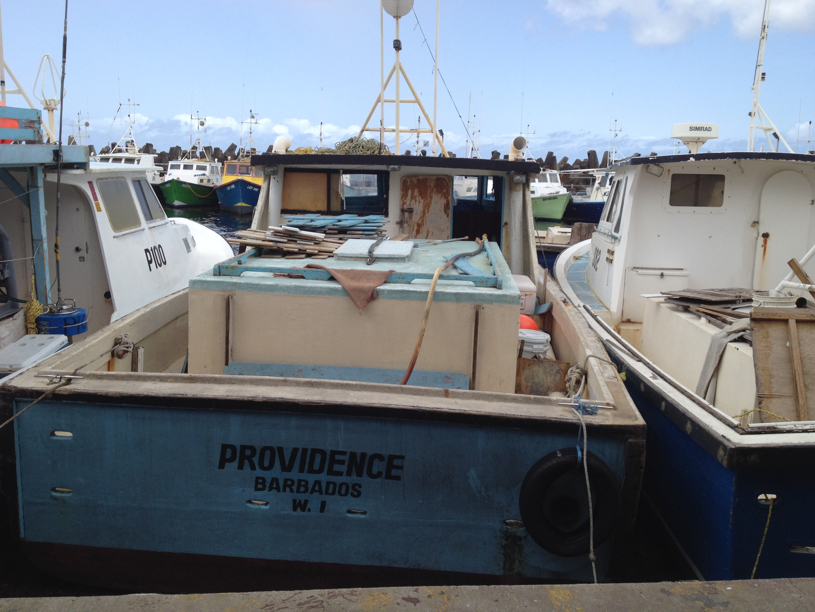
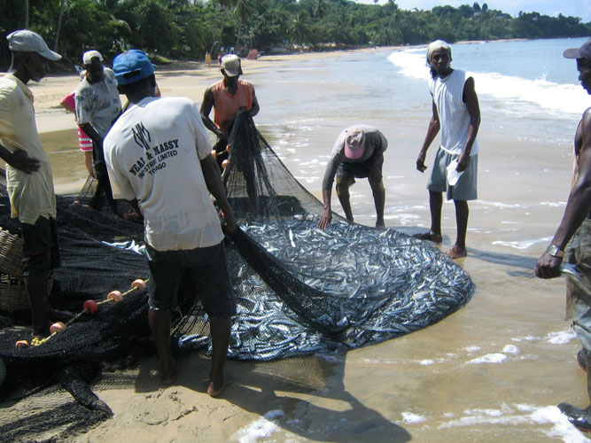

Barbados

Mission Report
+

Project: Technical support to develop model legislation, protocols, guidelines for health and food safety related to fisheries and aquaculture in CARIFORUM States
Funded by the European Union
Managed by the International Institute for Cooperation in Agriculture (IICA) and the Caribbean Regional Fisheries Mechanism (CRFM)
July 2015


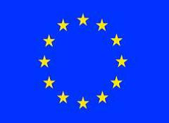

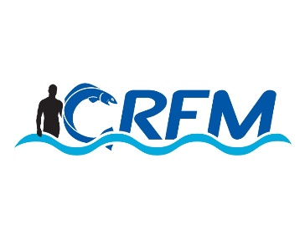
Contents

Mission Activities 3
Meeting Notes 3
Inception Meeting (Fisheries Division) 3
Fisheries Sector Meeting 3
TNINT 3
National Consultation 4
Appendix | Document Lists 6
Documents Collected 6
Presentations 6
Photographs 6

Mission Activities
The mission visit to Barbados was undertaken between the period May 31-June 3, 2015.
The visiting team members included Legal Consultant and Team leader Chris Hedley and Dr. George Grant, SPS Consultant .

Meeting Notes

Inception Meeting (Fisheries Division, TNINT Representatives)
The consultants met at the Offices of the Agricultural Health and Food Control Programme (NAHFCP) conference room located at Welches‘s Plaza in St. Michael with a representative group of senior staff members and Chief Fisheries Officer of the Fisheries Division. Also present were representatives from the regional IICA, FAO officers ,as well as, a representative from the MAFFW. Members of the Barbadian press and the CRFM Public Relations Officer were in attendance.
An official welcome was tendered by the Chief Fisheries Officer who in her presentation gave as brief overview of the Fishery Sector in Barbados who stated that the Fisheries Division was mandated to manage and develop the sector .In so doing the Division was responsible to undertake the registration of fisher folks and the inspection and registration of vessels and fish processing facilities. There were about one thousand participating fishing vessels comprising day boats which ply their trade on a daily sea to land basis and the larger iced vessels which may be at sea for up to three weeks at a time. The approach to fish preservation was mainly by the use of so-called ice boat. It was pointed out that approximately 3-5 metric tonnes are harvested annually with dolphins, tunas and flying fish species forming the primary catch. Mention was made of the various challenges faced by the Division in undertaking its mandate. This presentation was followed by one given by the representative of the BNSI
Mr. Hedley in turn gave a brief review of the rational and expected outcomes of the consultancy and by extension the CRFM project of which he reminded participants was just one component of a larger project of forty- two months which will impact the various member CARIFORUM Member States .He invited participants to give their own perspectives on the consultancy so that the feed - can serve to inform the final outcomes/recommendations to be made by the consultants . A frank and spirited discussion followed the presentations
Highlights of the discussion included :
- Project comes at interesting and important time for Barbados. Legislation is fragmented and out-dated. Need for revision and updating – environment is basically that we need to build from scratch. Protocol approach suggested by consultants was welcomed. Mention was made of specific need for protocols for tuna, dolphin fish, flying fish.
- The NAHFSC was considered the policy making body for food safety issues,
- Barbados not yet on the EU approved list of Third countries exporting to the EU;
- Barbados member of ICCAT ;
- Barbados has in place Draft Food safety and animal health policies and Fishing Act;
- There is limited trade – what is exists is either within Caribbean, or to US.
- EU inspection visit in 2008-Impending EU inspection visit soon but with several challenges being faced to achieve compliance;
- Challenges included legislation, infrastructural, training of personnel among others;
- Protocols for dolphins, tunas shell fish required and regulations for IUU;
- Note was also taken of the newly promulgated US modern Food Safety Act(US-FSMA) and its possible impact on Barbados export fishery initiatives.
- CFO commented that Barbados and regional generally need to present stronger front to EU
- Much potential in regional market; but often traditional / cultural views limit trade; so the question is how do we unlock that, and free up trade in the region.
- Comments were also made about the impact on national food security and prices if Standards are set too high – is this realistic for a small island like Barbados?

Fishers / Vendors Meeting
Meeting was arranged for approximately ten (10) fishers from the cooperative at the Fish Market Landing site.
In addition to the consultants , others present were the Fisheries Officer ,the manager of the Commercial Fish Market /Processing Facility Complex and the Quality Control Officer which is
These representative fishers voiced their concerns re such issues as fish standards application and the current pricing system. ice usage and quality. They enquired as to how the project would impact their operations. All seem desirous of entering the EU export trade.

Site Visits
Site visits to the Barbados government operated Fish Market ,processing facility and associated landing site were under taken, as well as, visit to a designated private sector fishing facility.

TNINT Meeting
- We need guidance / policy behind regulations
- CH explained next consultancy
- B observed current team needed to be involved
- CH explained plan to include national consultant
- Discussion on who would be best placed to attend meeting

National Consultation
This meeting was held at the Accra Hotel Conference Room and involved a wide cross section of the technical personnel of the various competent authorities which deal with food safety and quality assurance along with representatives of the private sector stakeholders.
A brief welcome and introduction was done by the Chief Fisheries Officer along with presentations from Chairperson of the NAHFSA Committee and the Representative from IICA.
These were followed by the a presentation by the consultants dealing with the project aim, deliverables including issues of governance and coordination aimed at positively impacting trade access and competitiveness both by member states and the region.
- Among the challenges perceived were those of;
- Regional/Country representation at the levels of the international Competent Authorities
- Laboratory Support systems/accreditation etc
- Training at the various levels to include fisher folks.
- Cruise ship markets and the impact of food safety measures
- Product Traceability
- Pilot studies at the processing operation level.
- Regional Harmonization and the movement of agricultural goods and services.
Governance group
- Policy should start at the national level; several components of policy were missing:
  - The idea came though of having an approved list of vendors that could provide capacity building and training.
  - Official controls – validation of the food safety system needs upgrading (training, resources)
  - Constrained finance is a key concern
  - Capacity building – SOPS, manuals, guidelines, etc. were all required
- Regional mechanism
Aquaculture
- Starting from ground zero
- A stakeholder advisory group should be established, reporting to CFO
- This could be establish policies, etc. best fit models
- Group would also assess existing aquaculture proposals
Import/Export Markets
- Need to be clear about who CA is, and how to use them and what they can provide
- Interest remains in EU markets, but seen as a long term goal

Debriefing Meeting
A summary of the major challenges and issues were considered by a combined meeting of participants from the NAHFCP,BNSI EH and Fisheries Division.
The major issues raised were :
- Barbados ‘ inability to be compliant with international export requirements is a continuing concern - EU inspection mission is anticipated in the near future
- Concept of model legislation would be helpful
- Streaming of export initiatives concept would also be helpful
- Deficiencies in monitoring, legislative underpinning and enforcement are all key issues
- Manuals / protocols for markets, vending and landing operations etc. are also needed – interest in developing this at the national level.
- Traceability systems need to be improved.

Appendix | Document Lists

Documents Collected
1. Fisheries Act cap 391 (1993)

2. Markets & Slaughter Houses Act cap 265

3. Heath Services Act (cap 44) and (Food Hygiene) Regulations

4. New Animal (Diseases and Importation) Act

1. EU Country review questionnaire response

2.& 3 EU report & Barbados response

4. FAO infrastructure/fish inspection systems review

